Packet Tracer – QUIZ Configuring OSPFv2 in a Single Area
Topology
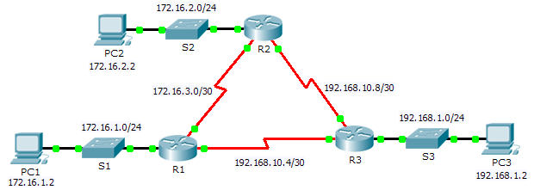
Addressing Table
Device | Interface | IP Address | Subnet Mask | Default Gateway
R1 | Fa0/0 | 172.16.1.1 | 255.255.255.0 | N/A
 | S2/0 | 172.16.3.1 | 255.255.255.252 | N/A
 | S3/0 | 192.168.10.5 | 255.255.255.252 | N/A
R2 | Fa0/0 | 172.16.2.1 | 255.255.255.0 | N/A
 | S2/0 | 172.16.3.2 | 255.255.255.252 | N/A
 | S3/0 | 192.168.10.9 | 255.255.255.252 | N/A
R3 | Fa0/0 | 192.168.1.1 | 255.255.255.0 | N/A
 | S2/0 | 192.168.10.6 | 255.255.255.252 | N/A
 | S3/0 | 192.168.10.10 | 255.255.255.252 | N/A
PC1 | NIC | 172.16.1.2 | 255.255.255.0 | 172.16.1.1
PC2 | NIC | 172.16.2.2 | 255.255.255.0 | 172.16.2.1
PC3 | NIC | 192.168.1.2 | 255.255.255.0 | 192.168.1.1
Objectives
Part 1: Configure OSPFv2 Routing
Part 2: Verify the Configurations

