ANALYSIS PROGRAM BUSSINESS
DEVELOPMENT SERVICES (BDS) AND
EXPANSION OF NETWORK PERFORMANCE
MANAGEMENT PRODUCT MARKET FOR
SMALL AND MEDIUM ENTERPRISES (UKM) IN THE REGION GERBANGKERTOSUSILA

Dr.Priyono
Management Science Department, Faculty of Economics,
PGRI Adi Buana University,Surabaya, East Java of Indonesia
Dr. Rahayu Puji Suci
Management Science Department, Faculty of Economics Widya Gama University,Malang, East Java of Indonesia Ir. Pontjo Bambang Mahargiono, MM.
Management Science Department, High School Economics (STIESIA),
Surabaya, East Java of Indonesia

Abstract
Some program development support system for cooperative effort, Micro, Small And Medium aims to simplify, accelerate and broaden access Cooperatives, Micro, Small and Medium Enterprises to productive resources to be able to take advantage of the opportunities and potential of local resources to develop KUMKM businesses, as well as adjustment scale its business to be more efficient. Results if the data using the method of AHP and expert choice software assistance to the respondents' answers on a variety of criteria that affect the Program Business Development Services (BDS) Against management Performance Network Expansion Markets And Products For Small and Medium Enterprises (UKM) in Region
Gerbangkertosusila.

Keywords: BDS Program, Performance, Product UKM

Introduction
Cooperative development of Micro, Small and Medium Enterprises ( KUMKM ) is a strategic step , because it has a major role in improving the living standards of the people at large to support the economic growth of the region , as well as efforts in the creation of new jobs . This is demonstrated by the existence of UMKM which is the biggest part of the economy - social residents of East Java . KUMKM large role demonstrated by the contribution to the GDP formation KUKM East Java and its ability to create jobs and provide employment .
In times of crisis , the business scale of Micro, Small and Medium Enterprises ( UKM ) have shown toughness in the face of macroeconomic shocks . Scale is even able to grow at a significant rate . Therefore, the future economic development , the Medium Term Development Plan (RPJMD ) East Java is directed to further strengthen alignments to the economic empowerment of the people . This business through the growth and development of a comprehensive and integrated so that the existence of SMEs can be one of the main pillars in boosting the regional economy.
Under conditions of diversity , Cooperatives and UKM in East Java until December 31, 2004 ( ( 1 ) ) of 15 867 units of Cooperatives and UKM 2.3 million . Also based on the business activities of Cooperatives , Micro, Small and Medium Enterprises engaged in nearly all types of field operations and acts as the main actors of development in every sector and economic activity .
In general , the problems faced by UKM are : ( a) the limited ability to market access and market share expansion , ( b ) less able to access the information ( c ) are less able to take advantage of technology and did technology sharing , ( d ) are less able to access the sources of funding , particularly on bank credit , and ( e ) the low quality of human resources . Besides that , in general UKM are also less capable of organization and management . This latter problem can inhibit the competitiveness of UKM due to weak collaboration network .
Some program development support system for cooperative effort, Micro, Small And Medium aims to simplify, accelerate and broaden access Cooperatives, Micro, Small and Medium Enterprises to productive resources to be able to take advantage of the opportunities and potential of local resources to develop KUMKM businesses, as well as adjustment scale its business to be more efficient.
Recognizing the problem above, the empowerment of UKM conducted focus on strengthening the capacity or the quality of its human resources. This is because, according to BPS (1998) ((2)) or 97.4% majority of small businesses in Indonesia educated SLP down. This low level of education can affect the spirit of entrepreneurial spirit (entrepreneurial spirit). UKM are often easily satisfied with what he had accomplished. In fact, it is not uncommon UKM are less able to fulfill that commitment to get a big order. Quality products including product design is often less attention to be able to follow the tastes of consumers.
Other efforts are also possible assistance to UKM, both by government agencies and non-governmental. Business development service agency (LPB) or also popularly called Business Development Services Providers (BDS-P) is one of the strategies in empowering UKM. During the development of such institutions has long pioneered, starting from the center of consultations involving the college in 1993, then changed to Clinical Consultancy Business (KKB) and in 1998 changed again to PER (Central People's Economy).
There are approximately 150 BSD in East Java, which consists of institutions from the affiliated college / higher education and the private sector. BDS basically perform the function of business services for UKM such as consulting services, business plans, improve the organization and management, capital management and the possibility of cooperation with other mintra.

Theoretical Framework
Business Development Services ( BDS ) are services that can improve : ( i ) the performance of a business , ( ii ) market access , and ( iii ) the ability to compete . The definition of " business development services / business development services " in these Guiding Principles include coverage of business services , both strategic and operational . BDS is designed to serve individual businesses , not for the larger business community . Business Development Services / Business Development Services ( BDS / LPB ) is a service provided by the Service Organization Providing Business Development Services ( LPLPB ) to KUKM to run the business . These services are dynamic , covering broad aspects KUKM as needed , but not including financial services .
BDS also has a relatively diverse definitions , namely ( Soetrisno , 2002:10) ((3)) can be interpreted Briefly BDS sebgai nonfinancial services aimed at improving the performance of an individual company . Specifically , the Committee Of Donor Agencies For Small Enterprise Development defined BDS as a non- financial services that improve the performance of the company , its access to markets , and its ability to compete , which includes a wide variety of business services designed to serve the needs of individual companies , not to serve the community business extensively .
Different definitions formulated by Boosting Businesses ' Advisory Services ' : in a 1985 OECD study ( ( 4 ) ) , BDS is a non - financial services that aim reningkatkan functioning of UKM in a wide range of activities and improve their performance, through the provision of external advice and expertise in short term or temporary , as a complement to the internal resources of the company concerned .
Based on these definitions , it is understood that the BDS is noh financial services aimed at improving performance , access to markets and the ability of a company to compete individually , are available for short term or temporary .

Thinking Framework
Each area has a small and medium enterprises (UKM), small and medium Enterprises (UKM) illustrate the potential of an area or region's ability to produce products, creating value, leveraging resources, providing employment opportunities, income communities and local governments, and have prospects for improving productivity and investment. An SME products (UKM) is said to excel if it has high competitiveness in the market. But in order for the product has high competitiveness it is necessary to add value. As well as the southern coastal area of East Java Province.
Potential of small and medium enterprises (UKM) in the region Gerbangkertosusila are the focus of this research can then be mapped into several sub-sectors of the food crops sub-sector of agriculture and horticulture, plantation sub-sector, sub-sector, forestry, fisheries sub-sector, livestock sub-sector, sub-sector of the industry , and tourism sub-sectors.
So that the product of the sub-sector has a high competitiveness, it is necessary to add value. However, due to several limitations such as availability of raw materials, processes, and markets do not lead to all small and medium enterprises (UKM) in the region Gerbangkertosusila of these subsectors can be a plus. By reason of these limitations, it is necessary to investigate the small and medium enterprises (UKM) in the region Gerbangkertosusila what needs to be prioritized to be value-added. Results are expected to be taken into consideration in developing the East Java Government small and medium enterprises (UKM) in the region
Gerbangkertosusila.

Conceptual Framework For Research
Based on the exploration results of scientific thought clan theory developed in this study, can be abstracted within the theoretical framework of the study as follows:
Factors ↔ BDS planning
Factors ↔ implementation of BDS
Factors ↔ BDS development↔ motivation factor
Program Business Development Services (BDS), is a business development services to improve corporate performance, market access and competitiveness, which are non-financial. These services can be grouped into:

- planning factor
the range of services related to the planning aspects given in an effort to improve performance consisting, dari_: information services, consulting services, coaching / mentoring, business development and proposal writing.
- implementation factors
the range of services related to aspects of the implementation are given in an effort to improve performance consisting of: training services, facilitation in organizational development and management, and facilitation in obtaining capital. business contacts, facilitation in expanding markets, and facilitating the development of technology.
Performance is a result of the implementation of the good work that is physical (material) and intangible (non-material) with indicators of achievement of the work compared to predetermined targets related to: capital, business unit, aspects of production, marketing, turnover and operating profit
Based on the background, the formulation of the problem as well as the theoretical framework of the research hypothesis can be formulated as follows:
- Business Development Services (BDS), which consists of the factors of planning, implementation factors, development factors and motivational factors have a significant influence on the performance of managers of UKM in Gerbangkertosusila.
- Factors dominant influence on the performance of the implementation of UKM managers in Gerbangkertosusila.

Methods
Selection Of Respondents
The study involved two components, namely respondents respondent experts and consumers directly. Respondents experts involved in total consists of 100 members, namely Academics (30 people), Bureaucracy (50 people) and Practitioners (20) A description can be seen in Table 3.1 below. Table 3.1. Instant Expert Respondents Involved in Research.
No | Description
1 | Department of Agriculture Regional
2 | Department of Animal Husbandry Regional
3 | Department of Industry
4 | Department of Forestry
5 | Department of Fisheries and Marine
6 | Department of Tourism
7 | Lecturer Agricultural Technology Studies Program
8 | Studies lecturer Livestock Products Technology
9 | Industrial Technology lecturer
10 | Environmental Observer
11 | social observer
Respondents direct consumers to consumer preference assessment of product attributes, as many as 1600 people includes Regency society (Gresik, Bangkalan, Mojokerto), Surabaya and Sidoarjo as a producer of small and medium enterprises (UKM) which used to be the producer for the small industrial raw materials and small industry players in four districts.

Data Collection Methods
Data collection methods used are as follows:
- Research literature, namely the book search, research, magazines and other sources related to the problem under study.
- Field research, ie making observations on the industry which is the object of research,
to see firsthand the activities undertaken, production systems, products, facilities and ancillary factors, data collection directly with observation and interviews. Types of data collected in this study consisted of primary data and secondary data.
Then the primary and secondary data were analyzed using one of the methods Multi Criteria Decision Making is Analytical Hierarchy Process.
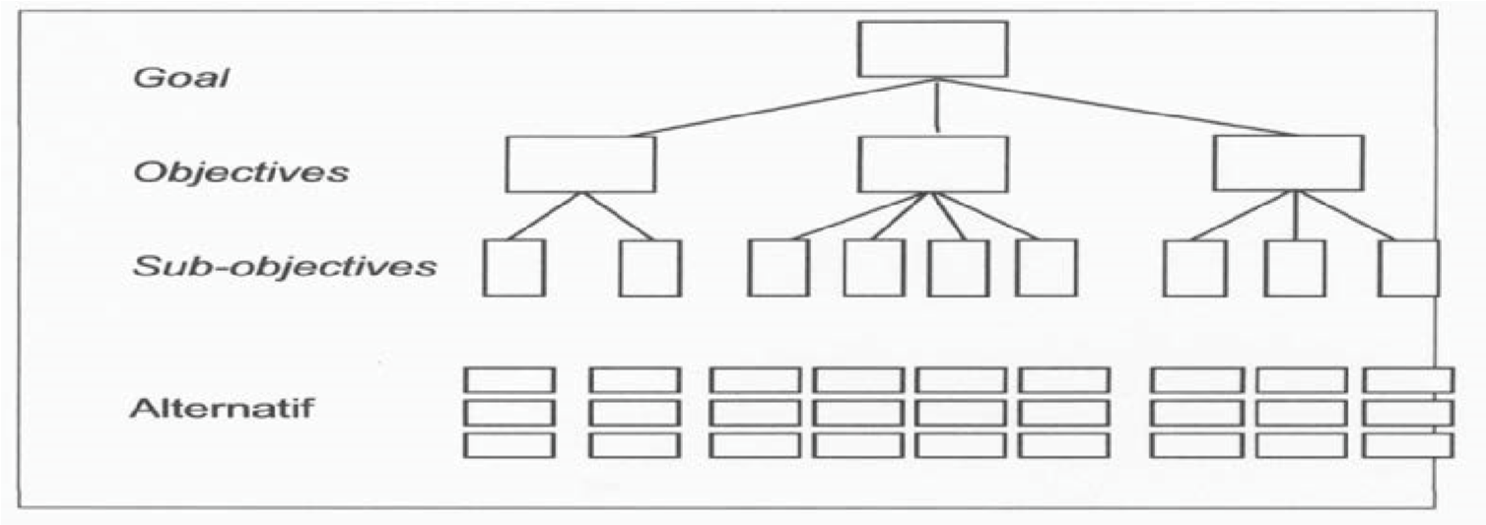
Decision makers then make a simple comparison to the priority hierarchy of
the entire existing alternatives.

Figure 5.1 Hierarchy of Decision

This grouping includes creating a hierarchy (ranking) of the elements of the decision and then make comparisons between each pair in each group, as a matrix. After that will be gained weight and inconsistency ratio for each element. Thus it would be easy to test the consistency of the data (Saaty, 1980 ((9))).

Data Collection With A Pair Wise Comparison
Assessment questionnaires pair wise comparison to determine priorities in the region Gerbangkertosusila flagship product were calculated using pairwise comparisons (pair wise comparison) developed by Thomas L.
Saaty (Marimin, 2004). ((9)) rating scale pairwise comparisons are as follows:
Table 3.2 Comparative Assessment Scale
interest rate | Explanation
1 | Just as important
3 | Slightly more important
5 | More important
7 | It is more important
9 | It must be important
2,4,6,8 | If undecided between two adjacent values
1/(1-9) | In contrast to value the importance of scale 1-9.

In this study we used the comparative scale of 1 s / d 9 (Table 3). Saaty has shown that the value of a comparative scale 1 s / d 9 is the best, which is based on consideration of the high accuracy, as indicated by the RMS (Root Mean Square) and MAD (Mean Absolute Deviation) on the various problems (Arkeman, 1999) ((9 )).
AHP method for the number of samples is relatively large, then the steps are as (and Sally Forman, 2001) ((9)): Calculation of the geometric mean (geometric mean), Based on all respondents answer scores, averagegeometric mean each pair being compared then calculated by the following formula.
n
∑log Xi
log G = ^{i=1} n

Description:
Log G: logarithm of the geometric mean xi: the value of the respondents' answers i n: number of respondents
Geometric mean calculation is done for each pairwise comparison of respondents. geometric mean score of each pair of options to be used in priority setting.
The equation used is as follows:
- Calculating eigen value of each line:
λi =∑N = W I
j=i aij Wj
- Calculating eigen vector of each line:
(EV)k = N1 j∑N=I ∑Na kj aij

i= j
- Calculate l
1 N
λmaks = N _{i}∑=_{I} λi
- Calculate the consistency ratio:
CR ₌ ^{CI} NRC = Bilangan Konsistensi random
NRC

Data Processing
Percent of the data processing and then do the ordering from greatest percentage to the smallest. Sequencing was used to determine the level of interest of small and medium enterprises (UKM) from the experts who know the products featured in the Gerbangkertosusila (Gresik regency, Bangkalan, Mojokerto regency, Surabaya and Sidoarjo) Expert used herein are the expert of experts who considered most knowledgeable about Gerbangkertosusila flagship product in the region (Gresik regency, Bangkalan, Mojokerto regency, Surabaya and Sidoarjo interest rate small and medium enterprises (UKM) need to know to determine the priority of small and medium enterprises (UKM) that need to be developed by the government of East Java

Discussion
Small And Medium Enterprises (UKM)
Poverty alleviation is basically done through increasing the income of the poor by expanding job opportunities and business spending as well as reduce the burden by facilitating access to education , health and infrastructure . Poverty alleviation is basically done through increasing the income of the poor by expanding job opportunities and business spending as well as reduce the burden by facilitating access to education , health and infrastructure .
To expand employment and business creation , poverty alleviation and empowerment through MUKM Development .Development of small and medium enterprises in the face of regional and global markets should be based on hard efforts and continuously in the UKM as a formidable effort . Therefore UKM products cultivated at least have a comparative advantage , even highly desirable to have a competitive advantage . Business Development Services ( BDS ) is an UKM business development efforts systemically , so that UKM 's in it has a chance to be a reliable and competitive business . UKM business development strategies should be based on the strengths and challenges , Olehkarena should be strongly supported primarily by a lack of access to funding , markets , sources of raw materials , as well as information technology and management .
Keywords : Small and Medium Enterprises ( UKM ) , Regional and Global Markets , Economic Security , Economic Mutual System , Cluster Systems Business , Business Centers , Busines Development Sevices . business qualifications such as what are the odds can participate actively in the free trade . Of the commodity which is likely opportunity to be actively traded on the regional market / competitive globally , it seems there is no choice , but that have a comparative advantage ( comparative advantages Commodities are mainly derived from the agricultural sector, particularly the plantation sub-sector and sub-sector in particular marine fisheries sector and industrial sector, particularly the manufacturing subsector and small industries . Then qualifying businesses that have opportunities to develop their business as well Infokop XX No. 25 of 2004 ( ( 9 ) ) into the Indonesian economy is the driving force of business activities that have experience / records ( track record ) is good , especially during the last ten years . Further on the basis of experience , especially in times of crisis the last seven years , the option of prioritize business activities ( entrepreneurs ) with small and medium -scale enterprises ( UKM ) is a pretty wise choice . Therefore , what is important is how to examine the possibility that economic activity will occur in the world , regional and in Indonesia itself within the next five years . How chances for UKM , to develop its business in a competitive market , so in addition to increasing the quantity and quality of their business can also strongly support the Indonesian economy .
Business Development Service ( BDS ) is an organization that provides advocacy services , mediator , and special assistance in the field of finance to UKM . Financing BDS is well positioned to undertake the role of the advanced facilities of the proposals submitted and UKM . Focus BDS for Small Business , with the aim of identifying and documenting best practices in this area . BDS Working Group prepared a draft document that outlines the principles of guidance ( as it is called Guidelines) based on conference papers and discussion . The concept is the main basis for discussion and to develop consensus on the principles for donor intervention in BDS . UKM empowerment can only be achieved with hard work orders with the business community and society at large . Therefore the synergy between the various elements - it needs to be improved .

Small And Medium Enterprises (SME) And Institute Of Business
Development (BDS) In Gerbangkertosusila
Small and Medium Usaka development programs through Business Development Services ( BDS ) in Gerbangkertosusila with strengthening method in the form of centers has developed very rapidly . The types of business centers can be classified into :

Food and drink↔
Embroidery , convection and ikat↔
Matting and other art↔ Metals and automotive spaerpart↔ Agro businesss.
Fisheries↔
Livestock Chicken↔
Mebelair↔
Tile↔
Gold / silver↔
Special Products ( shutel cock , interior valance , skull cap , leather tanners )↔
BDS concept of blueprints , business development services provided in the BDS to UKM which include activities such as :
- . service information
- . consulting services
- . training services
- . To provide technical guidance / assistance
- . Conducting business box
- . Facilitation in expanding market
- . Facilitation in expanding capital
- . Facilitate the development and management orgasisasi
- . Facilitating the development of technology
- . Business development proposal
Number of BDS institutions in Gerbangkertosusila increased from year to year , so does the number of UKM that obtain the services of BDS . Contribution of UKM in Gerbangkertosusila reflected in employment .
Ministry of Cooperatives and UKM to change the paradigm development Business Development Services - Provider ( BDS-P/Lembaga Business Services / LPB ) Cooperatives and UKM from being so dependent on the government to be more independent and professional and able to partner UKM in the region .
If you listened to some of the results of monitoring ex BDS 2001 - P , there are several problems that must be overcome so that BDS - facilitated P is able to give meaning to their development . In the conception of the assignment to the BDS - P to develop UKM in the center in addition to the initial capital reinforcement equivalent (MAP ) through cooperative is ideal , meaning that the market was already provided by the government and their funding support .
The problem is , the capacity of BDS - P which was tasked to develop UKM disentra not all understand or be able to carry out their duties .
In addition , existing UKM disentra feel no significant role undertaken by BDS - P . In other words , the communication between BDS - P with UKM in the center does not or has not happened
Consequently there BDS - P which is capable of carrying up to international markets proxies , but the numbers are so few . While that is happening is much more that has not been able to carry out the duties and functions of its consultation effectively . BDS - long condition in general P is the majority lack the competence and readiness of human resources so that less able to perform the role of business services for UKM . In addition they also rely project or budget .
While the new paradigm that will be implemented is how to make BDS - P is able to live as an independent and professional organizations , on the basis of capabilities and advantages of UKM and become partners in the region . BDS-P/LPB basically perform the function of business services for UKM such as consulting services , business plans , improve the organization and management , capital management and the possibility of cooperation with other mintra .
In Indonesia, many BDS Providers that provide a variety of services to improve business UKM , including bridging the UKM banking . However , only a few have BDS consultants who have a good relationship with the bank . BDS - P development laid out starting in 2001. There are approximately 150 BSD in Gerbangkertosusila consisting of institutions of higher education and private affiliates .

Results Analysis Method Of Evaluation Program Ahp Business Development Services (BDS) And Expansion Of Network Performance Management Product Market For Small And Medium Enterprises
(UKM) In The Region Gerbangkertosusila
By definition Business Development Services ( BDS ) are services that can improve : ( i ) the performance of a business , ( ii ) market access , and ( iii ) the ability to compete . The definition of " business development services / business development services " in these Guiding Principles include coverage of business services , both strategic and operational . BDS is designed to serve individual businesses , not for the larger business community . Business Development Services / Business Development Services ( BDS / LPB ) is a service provided by the Service Organization Providing Business Development Services ( LPLPB ) to KUKM to run the business . These services are dynamic , covering broad aspects KUKM as needed , but not including financial services .
In the analysis of research results AHP Methods In Evaluation Program Business Development Services ( BDS ) Against Pengelolahan Performance Network Expansion Markets And Products For Small and Medium Enterprises ( UKM ) in Gerbangkertosusila region there are two important aspects to be targeted for program continuation BDS , both aspects are :
- . Program to improve the operational aspects of the BDS
- . Program to improve the institutional aspects of the BDS
The choice of these two aspects of the administration of due performance and network expansion market for small medium enterprises ( UKM ) in the region can not be separated from strengthening gerbangkertosusila BDS as an institution that serves to integrate kegiatan0 - sector economic activity , the creation and expansion of employment opportunities and the basis for economic development independent
Besides both these aspects , some related criteria Evaluation Program Business Development Services ( BDS ) Against Pengelolahan Performance Network Expansion Markets And Products For Small and Medium Enterprises ( UKM ) in the region Gerbangkertosusila an important part of the development aspects of the BDS itself is : 1 . training program for UKM
- . provision of consultancy and advisory services for UKM
- . marketing support for UKM
- . providing a variety of information for UKM
- . providing business development support for UKM
- . petrified technology transfer
- . promotion of business networks for UKM
Results if the data using the method of AHP and expert choice software assistance to the respondents' answers on a variety of criteria that affect the Evaluation Program Business Development Services ( BDS ) Against Pengelolahan Performance Network Expansion Markets And
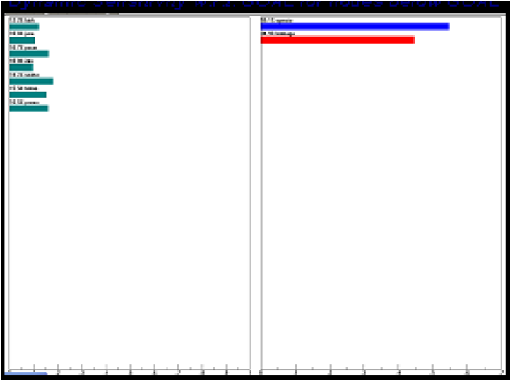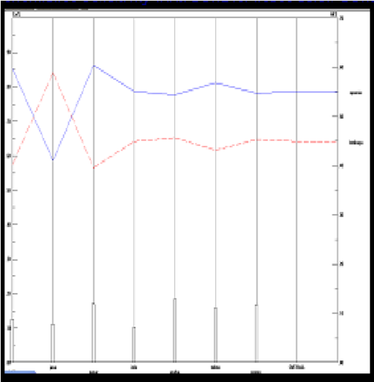
Products For Small and Medium Enterprises ( UK
M ) in Gerbangkertosusila
region is presented in Figure the following :

Figure 1. Graphs and Dynamic Performance Evaluation Program Business Development
Services (BDS) Against Pengelolahan Performance Network Expansion Markets And
Products For Small and Medium Enterprises (UKM) in Region Gerbangkertosusila
Based on analysis of the operational aspects of the AHP method BDS occupies the first priority in an effort to improve the performance and administration of network expansion market for small and medium enterprises (UKM) in the region gerbangkertosusila. Further criteria are very important in the operational aspect is the provision of business development assistance who finished first and second best marketing assistance it can also be seen in the following figure:
Figure 2. Chart comparison of the various criteria Evaluation Program Business
Development Services (BDS) Against Pengelolahan Performance Network Expansion
Markets And Products For Small and Medium Enterprises (UKM) in Region
Gerbangkertosusila

Through AHP method can also do various simulations of aspects and criteria on Program Evaluation Business Development Services (BDS) Against Pengelolahan Performance Network Expansion Markets And Products For Small and Medium Enterprises (UKM) in Region Gerbangkertosusila by raising or lowering the most sensitive criteria which can change the priority -priority or sequence of these criteria of ≥ 10%.
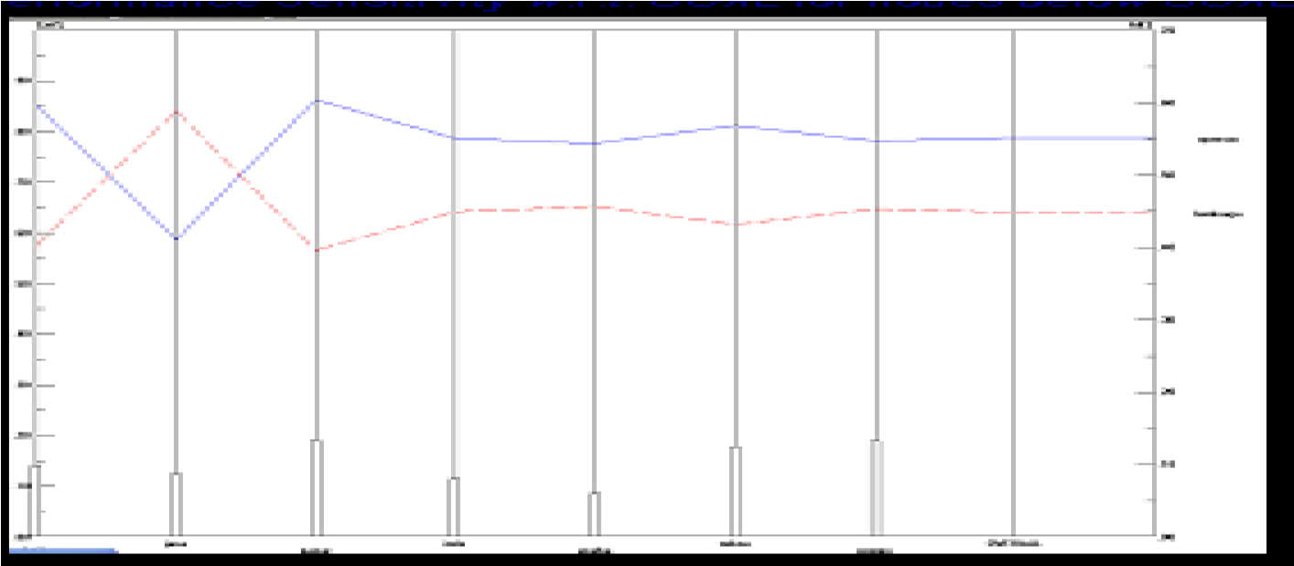

Figure 3. If the Dynamic Performance and Business Development Assistance For UKM Actors Promoted ≥ 10%.
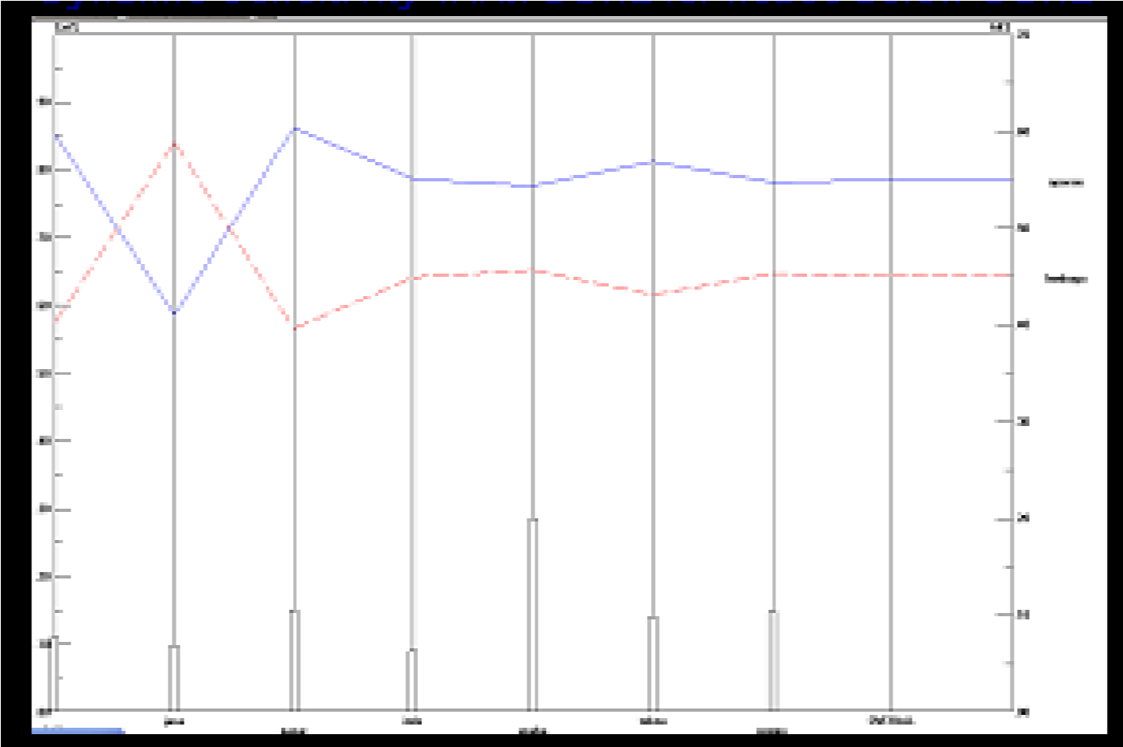
Figure 4. If the Dynamic Performance and Business Development Assistance For participants ≥ 10% of UKM Relegated.

Based on Figure 3 and Figure 4 shows that with the increase or decrease of the most sensitive criteria in the Evaluation Program Business Development Services (BDS) Against Pengelolahan Performance Network Expansion Markets And Products For Small and Medium Enterprises (UKM) in Gerbangkertosusila region did not change the order of aspects that need to be the level of operational aspects of BDS as the main priorities that need to be ditingkakan BDS in order to strengthen the role of UKM in the economic system Gerbangkertosusila.

Conclusion
Based on the analysis and discussion in the previous chapters, it can be concluded as follows:
- Planning factors which include information services, consulting services, coaching / mentoring and business development proposal has dominant influence on the performance of managers of UKM in Gerbangkertosusila.
- The most fundamental problem faced by UKM in Gerbangkertosusila is a matter of marketing the product.
- Training provided by the Institute of BDS is still considered not effective, because less touching fundamental things that a manager needs of UKM in Gerbangkertosusila.

Advice
Several suggestions have recommended this research related to the development of UKM in the steak holder Gerbangkertosusila, Good
Government, Institution or the Iainnya BDS is as follows
- BDS programs in Gerbangkertosusila still needed to be able to continue to run with the concept improvements and priorities service.
- Matters related to the marketing of the product should be the top priority of the services provided by the Institute of BDS to UKM.
- Need formulation back system and training modules provided by the Institute of BDS to UKM with basic needs to the needs of UKM.

References
Anoraga, Pandji dan Sudantoko, Djoko. (2002), Koperasi, Kewirausahaan, dan Usaha Kecil, Jakarta, Rieneka Putra.
Irianto, Jusuf, 2001, Isu-Isu Strategis Pengembangan Sumber Daya Manusia, Surabaya:lnsan Cendikia.
Johnson C. Merle et al., 2004, Hond Book Of Organizational Performance, Analisis Perilaku dan Manajemen, Jakarta. Raja Grafindo Persada.
Menegkop & UKM, 2000, Strategic Planning For Co~operatives and Small and Medium Enterprise Development, Jakarta.
Neal,James E, 2003, Panduan Evaluasi Kinerja Karyawan, Jakarta: Prestasi Pustaka Publisher.
Pemprop Jatim, 2003, Analisis Indikator Makro Sosial Ekonomi Jawa Timur, Tahun 1998-20022, Buku 2, Ringkasan Eksekutif, Surabaya: Pemprop Jatim.
Santoso, 1999, SPSS Mengolah Data Statistik Secara Profesional, Jakarta, PT. Gramedia Pustaka Utama.
Soetrisno, Noer, 2002, Strategi Penguatan UKM Melalui Pendekatan Klaster Bisnis : Konsep, Pengalaman Empiris Dan Harapan, Jakarta: Lutfansah Mediatama.
Sofo, F., 1999, Human Resource Development: Perspective, Roles and Practices Choices, Australia: Business & Professional Pub.
Tambunan, Thulus TH., 2002, Usaha Kecil dan Menengah di Indonesia Beberapa Isu Penting, Jakarta :Salemba Em pat. ____________, 2002, Perkembangan Industri Skala Kecil di Indonesia,Jakarta: PT. Mutiara Sumber Widya.
Umar, Husein, 2004, Riset Sumber Daya Manusia Dalam Organisasi, Jakarta: PT. Gramedia Pustaka Utama.

