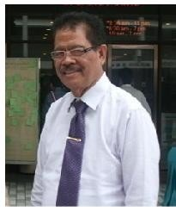

The Rector’s Greeting

Greetings and a warm welcome to the all academic researchers, practitioners, industry and business person as well as policy makers. Thank you for attended this 4rd international conference on Information Technology and Engineering Application 2015 (ICIBA 2015).

ICIBA is an annual event focusing on state of the art technologies pertaining to digital information and communications and its application in business and industry as well as government. The applications of advanced information technology to such domains as networking, security, engineering, education, finance, geosciences, health, transportation, supply chain management and logistics are among topics of relevance to ICIBA. The conference features keynote speakers, the best student award, poster award, technical open panel, and workshops/exhibits from industry, government and academia as well postgraduate student colloquium.

All papers for the ICIBA 2015 on this Conference Proceeding (ISBN) was indexed by EBSCO, Google Scholar, and sent to be reviewed by EiCompendex and ISI Proceedings. Our gratitude to all the participants who has take a part in this conference, I hope we can take the advantage of academic research findings, to have better insight about the importance of IT and business application, to the country’s economic development

Sincerely yours,
Prof. Ir. H. Bochari Rahman, M.Sc

RECTOR of BINA DARMA UNIVERSITY

PROCEEDING

INTERNATIONAL CONFERENCE ON INFORMATION TECHNOLOGY AND ENGINEERING APPLICATION 2015

IT and Engineering for Better life

Published by:
Pusat Penerbitan dan Percetakan Universitas Bina Darma Press
(PPP-UBD Press) Palembang
Proceeding International Conference on Information Technology and Engineering Application

CONFERENCE COMMITTEE

Muhammad Izman Herdiansyah, PhD, Universitas Bina Darma, Indonesia
Erna Yuliwati, PhD, Universitas Bina Darma, Indonesia
Dr. Sunda Ariana, M.Pd., M.M. Universitas Bina Darma, Indonesia Dr. Ahmad Syarifuddin, M.T., Universitas Bina Darma, Indonesia Prof. Dr. Aizaini Maarof, Universiti Teknology Malaysia.
Prof. Dr. Wan Nasir, Universiti Teknology Malaysia.
Prof Dr. Eko Indrajit, Higher Education Association Information And
Computer Science (APTIKOM), Indonesia
Prof Zainal A Hasibuan, PhD, Higher Education Association Information
And Computer Science (APTIKOM), Indonesia
Dr. Paulus Sukapto, Ir., MBA, Universitas Katolik Parahyangan, Indonesia
Dr. Ir. T. Ari Samadhi, Institut Teknologi Bandung, Indonesia.

REVIEWER & EDITOR

Leon Andreti Abdilah
PH Saksono
Erna Yuliwati
M. Izman Herdiansyah
Edi Surya Negara

Support by. Bina Darma University
Steering Committee ICIBA
Cover Design by. Deni Erlansyah
Printed in Palembang, Indonesia, Febuari 2015
CONTENTS

No Titel Page

INFORMATION TECHNOLOGY

30. | Study of Wavelet Transformation Method for feature Extraction Characteristics Based In Identifying Authenticity Indonesian Batik | 195 - 200
 | Fikri Budiman
31. | Distributed Penetration of Wireless Passwords For Wired | 201 - 207
 | Protected Access Type Security
 | Taqrim Ibadi, Muhammad Izman Herdiansyah, Yesi Novaria Kunang
32. | Correspondence Archival Information Systems | 208 - 213
 | In Bina Darma University
 | Edo Pratama, Leon Andretti Abdillah, Susan Dian Purnamasari
33. | Android-Based Bus Ticket Reservation Application  Fitriani, Leon Andretti Abdillah, Deni Erlansyah | 214 - 219
34. | Web Design As Support Promotion and Dissemination of | 220 - 223
 | Information Using Tabloid B-Smart
Rich Internet Application (RIA)
Sri Solmawati, Yesi Novaria Kunang, Wydyanto
35. | Analysis Network Security of Local Area Network (LAN) | 224 - 229
and Wifi in Dishub Kominfo Banyuasin
Ririn Pratama Endra Wijaya, Yesi Novaria Kunang, Widyanto
36. | Dictionary of Prabumulih Language-Based Android  Murdianto, Leon Andretti Abdillah, Febriyanti Panjaitan | 230 - 235
37. | Geographic Information Systems of Android-Based | 236 - 241
Residential Locations in Palembang
Lia Novita, Leon Andretti Abdillah, Ari Muzakir
38. | The Evaluation of Academic System of Bina Darma | 242 - 244
University on Students Satisfaction
Rahayu Amalia, Firdaus, Ahmad Haidar Mirza

39. | Application of Data Mining to Determine Students Interest in  Reading University Library Building Bina Darma Palembang | 245 - 249
Using Clustering Method
Lemi Iryani
40. | Decision Support System To Determine The Loan Nominal at | 250 - 254
KUD Mupakat Jaya Using Decision Tree Method
Mulia Puspita Sari, Ahmad Haidar Mirza, Fatmasari
41. | SMS Security System With Encryption Decryption Blowfish | 255 - 260
Algorithm Based on Mobile Android
Fitri Andiyani, Yesi Novaria Kunang, Evi Yulianingsih
42. | Implementation of Applications on The Store Hellen Jaya | 261 - 264
Using Rapid Application Development Method
Ibnu Khoirin, Marlindawati, Muhammad Sobri
43. | Website Design Using Responsive Web Design | 265 - 269
(Case Study: SMK YP Gajah Mada Palembang)
Yesi Ranita, Ilman Zuhri Yadi, Andri
44. | Information Systems Digital Library in Senior High School | 270 - 273
Nurul Iman Palembang Using Methods Zachman Framework
Firnando, Irwansyah, Ria Andryani
45. | Analysis System Service Application (SAP) Stafifng in | 274 - 278
 | TASPEN (Persero) Branch Palembang Using Human
Organization Technology (Hot Fit) Model
Muhammad Zulkarnain, Merry Agustina, Qoriani Widayati
46. | Evaluation Human Resourches Information System (HRIS) | 279 - 284
 | The University Of Bina Darma Using End User Computing
Satisfaction (EUCS)
Nina Dwi Putriani, Muhammad Nasir, Suyanto
47. | Evaluation Human Resourches Information System (HRIS) | 279 - 284
 | The University Of Bina Darma Using End User Computing
Satisfaction (EUCS)
Devi Udariansyah, Prihambodo Hendro Saksono, Ahmad
Haidar Mirza

ENGINEERING APPLICATION

47. Simulation of Catalyst Agglomerates Inuences on the 292 - 297
Catalyst Performance in Hydrogen Fuel Cells
Sutida Marthosa, Edward Roberts

INFORMATION

TECHNOLOGY
The 4th ICIBA 2015, International Conference on
Information Technology and Engineering Application
Palembang-Indonesia, 20-21 February 2015

E-Tracer System Design of Master of Information Technology
Bina Darma University Alumni Using Agile Methods Model

Devi Udariansyah, Prihambodo Hendro Saksono, Ahmad
Haidar Mirza

Universitas Bina Darma
e-mail: devi.udariansyah@mail.binadarma.ac.id, p.h.saksono@mail.binadarma.ac.id, haidarmirza@mail.binadarma.ac.id

Abstract

One indicator of learning outcomes and relevance of higher education to society is seen from the success of college graduates in entering the workforce. Thus, the college is responsible not only to equip graduates with specific competencies (learning outputs) but also must facilitate and bridge the graduates entering the workforce. The existence of the Career Center at the college reflects the responsibilities and higher education services for new graduates in particular, and students in general as a prospective graduate. College Career Center has a variety of functions, ranging from attempts introduction to the profession and employment, training to improve employability (readiness and ability to penetrate the world of work), and track the presence and gait after leaving college graduates, particularly associated with the transition period to enter the workforce. Overall career center functions can be implemented throughout the learning cycle in college, start early to enter the world of higher education to completion and enter the stage of life after high school. One way to obtain information related to the transition from college to work is to carry out a study known as the tracer study. Tracer study is the study of graduates of institutions of higher education (Schomburg, 2003). Another term that is often used is ”Graduate Surveys”, ”Alumni Researches”, and ”Follow-up Study”. These terms refer to the notion that ”almost” the same as the term tracer study by Cabrera et al. 2005, which henceforth will be used in this study. In this study the authors will build information systems tracer studies in Master of Information Technology University of Bina Darma using Agile Model.

Keywords : Tracer Study, Design, Agile Model

1 INTRODUCTION

One indicator of learning outcomes and relevance to the community college is a college graduate success in entering the workforce. Thus, the college is responsible not only to equip graduates with specific competencies (learning outputs) but also must facilitate and bridge the graduates entering the workforce. The existence of the Career Center at the college

reflects the responsibilities and higher education services for new graduates in particular, and students in general as a prospective graduate. College Career Center has a variety of functions, ranging from attempts introduction to the profession and employment, training to improve employability (readiness and ability to penetrate the world of work), and track the presence and gait after leaving college graduates, particularly associated with the transition period to enter the workforce. Overall career center functions can be implemented throughout the learning cycle in college, start early to enter the world of higher education to completion and enter the stage of life after high school.
One way to obtain information related to the transition from college to work is to carry out a study known as the tracer study. Tracer study is the study of graduates of institutions of higher education (Schomburg, 2003). Another term that is often used is ”Graduate Surveys”,
”Alumni Researches”, and ”Follow-up Study”. These terms refer to the notion that ”almost”
the same as the term tracer study would be used in this guide.
Master of Information Technology (MTI) Universitas Bina Darma is a graduate education program in engineering Informatics Graduate Program organized by the University of Bina Darma. MTI has a concentration of 5 fields of study, namely the Chief Information Officer (CIO), Software Engineering, IT Infrastructure, IT Entrepreneur and IT for Education. From a standing start on April 6, 2009 until today, Master of Information Technology (MTI) Uni- versitas Bina Darma has graduated approximately 300 students students. In the alumni data management, Master of Information Technology (MTI) Universitas Bina Darma not yet have specific systems that can be accessed online. Because alumni data management is still done manually by recording using office applications such as Microsoft Exel. This of course makes Universitas Bina Darma have difficulty managing alumni data MTI progressively increase. For the E-Tracer system Alumni is the right step to overcome the existing problems, because the system of the E-Tracer alumni can be accessed by potential alumni and stakeholders who want to see the alumni database information anywhere and anytime that is connected to the Internet. Of this problem, MTI already need to have a special system to manage data alumni is to build the E-Tracer system. Due to the existence of this system will not only be part of the post that helped admministrasi will work but all walks of life can access the online system. This system later than displaying information MTI alumni database search, the system also has the facility of filling the questionnaire alumni tracer study aims to find out what the alumni job after completion of the course, how the alumni waiting period to get a job, how do alumni about their experiences of taking courses in graduate program Master of Information Technology University of Bina Darma Palembang, to determine the number of alumni monthly income after their work, to find out what advice and input to the alumni of the graduate program Master of Information Technology University of Bina Darma Palembang future. Alumni tracer system also has the facility for alumni to fill out or make an announcement about the job or just provide information about IT. For alumni database information, the system will display the complete alumni data, ranging from nim, full name, address, phone number, and a valid email address. And alumni can also fill out the form containing the work of alumni employment after graduation and work at the beginning of the lecture. From the description above, in this thesis the author will try to build the E-Tracer Alumni systems using agile methods models (Widodo, 2007). And expected by the system of the E-Tracer is later Alumni alumni and prospective partner companies Universitas Bina Darma can register and can search for alumni data easily, quickly and accurately.

2 RESEARCH METHODOLOGY

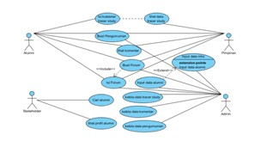

Figure 1: Usecase Diagram

2.1 Methodology

Methodology in software used to design or build a software, with rapid technological de- velopments software methodologies have also been changes or additions requirements. From the waterfall model (Pressman, 2010) to the incremental models. All the methodology developed previously not able to handle the possibility of changes or additions requirements. Software develop- ment methods have been traced back to 1957. In that year EA Edmonds has introduced adaptive software development process. ”Lightwight” is a software development method that developed in 1990, as a reaction to what is called the method of ”heavyweight”. Are char- acterized by their criticism of the waterfall method. In the 90s was introduced with the new methodology, known as agile methods, Agile said means is fast, lightweight, free to move, wary. Methodology known as agile methods have the flexibility to changes that occur during development. Even changes or additions during the last phase was resolved when using this methodology.

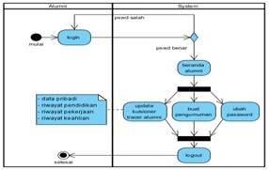

Figure 2: Graduation Activity Diagram

Agile Methods are developed because of the traditional methodologies are many things that make the development process can not be managed properly fit the demands of the user. The concept of Agile Software Development coined by Kent Beck in 2000 and 16 colleagues by stating that the Agile Software Development is a way to build software by doing it and
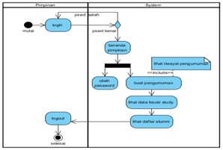

Figure 3: Leadership Activity Diagram

helping others build it once. The data required for the development of information systems
Alumni E-Tracer is as follows:

1. University Graduation of Bina Darma,

2. Data transcripts alumni of Master of Information Technology University of Bina Darma,

3. Data thesis title, and

4. Data lecturer Master of Information Technology University of Bina Darma.

2.2 Analysis Method

Specification of user needs is a picture of what will be the user in the system that will be developed starting from the manufacture usecase per actor, activity diagrams, class diagrams, and sequence diagrams. In this diagram Usecase describe and narrate the activities of each actor in the tracer system.

2.3 Design System

In the activity diagram below illustrates and tells the activity or activities of each actor in the tracer system. Show in Figure 1.

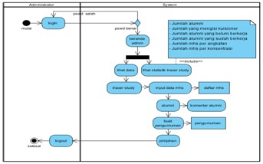

Figure 4: Administrator Activity Diagram

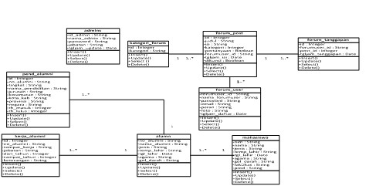

Figure 5: Class Diagram

In The diagram below illustrates the class and tells the relationship between classes that exist in the system tracer study. Show in Figure 2.
In the following diagram illustrates the sequence and interaction of each actor tells the tracer system. Show in Figure 4.

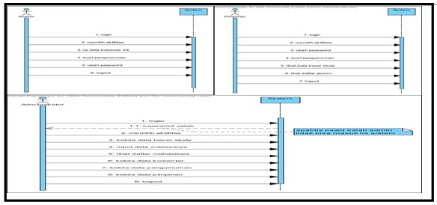

Figure 6: Graduations Squence Diagram

3 RESULT AND DISCUSSION

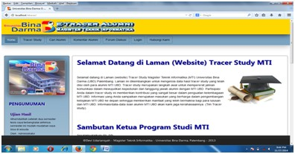

Figure 7: Main Menu Page

3.1 Main Menu Page

This page is the first page when visitors make accessing http: //e-tracer.mti/index.php. On the main page there are many links that can connect to other pages. Existing menu include Home, Tracer Study, Find Alumni, Alumni Comments, Discussion Forum, Login, and Contact Us. Here is the main page, here we can see the design of the design:

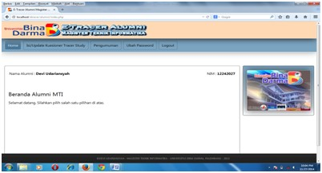

Figure 8: Page of Gradutions

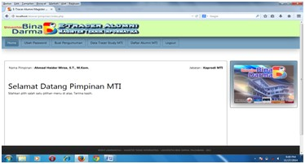

Figure 9: Leadrship Menu

3.2 Graduations Menu

On the home page, there are several menu of alumni for alumni, here we can see the design. Show in Figure 6.

3.3 Leadership Menu

On the home page contains menus for leaders to see the alumni data, etc. The following design Show in Figure 9.

3.4 Administrator Menu

On the home page admin functions to manage data on tracer system, following design
Show in Figure 10.

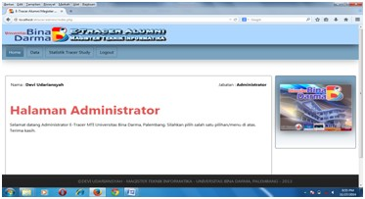

Figure 10: Administrator Menu

References

Cabrera et al. 2005. Apa dan mengapa tracer study. http://apmd.ac.id/tracer-study/ diakses pada tanggal 28 April 2014.

K. Beck, Extreme Programming Explained: Embrace Change, Addison Wesley, 2000.

Pressman, R.S. (2010), Software Engineering : a practitioner’s approach, McGraw-Hill, New York.

Schomburg, Harald. 2003. Handbook for Graduate Tracer Studies: Centre for Research on Higher Education and Work, University of Kassel, Germany.

Widodo, “Enhanced Extreme Programming: Adopsi Model Unified Process pada Metodologi eXtreme Programming”, Prosiding Seminar Nasional Teknologi Informasi (SNTI) Universitas Tarumanagara, Oktober 2007.

