ANALYSISI MPLEMENTATION OF E-LEARNING MODEL USING QUALITYE VALUATION METHOD(QEM) STUDY ON EDUCATION TECHNOLOGY OF BATURAJA UNIVERSITY
¹Anggraeni Agustin Muris, ²Sunda Ariana, ³M. Akbar
Magister Teknik Informatika
Universitas Bina Darma Palembang
E-mail : miss.muris@gmail.com

Abstract Rapid technological advances, a very influential impactinall aspects of life, including education Educationin the worldtoday, many whoal ready take advantage of technological developments, one of them byimplementinge-learningsystem, by applyingthis learning systemprovides many benefitsin education. Study Programin Educational Technology Teaching Facultyof EducationUniversity ofBalfour, isone of the coursesat the University ofBalfourwhohave taken advantage ofthe learningsystemof e-learning inteaching and learning activities, the system isapplied to themeetingswhichallowsalecturercan not meetin themeetingclass, such asthe provision ofcoursework,discussion, quiz, midtest, andothers with thehope of improving thequality ofteaching and learning, which in turn canimprove theachievement of students.
Howeverthere aresomeproblems and obstaclesin the implementation ofe-learningsystemis, among others: (1) a newpartiallylecturerinEducationalTechnology Studies Programthatusese-learning system leraning, (2) there aresomedifferencesin the use ofe-media applicationsforthe manufacture ofthelearningand(3) the lackof understandingfor somestudentsin theuse ofe-learningsystemso that they canaffectstudentlearning outcomes.
Problems arising from the above, the researcher intendstomeasure the comparativ euse of media applications in makinge-learning systems in Educational TechnologyStudies Program University of Balfour by using amodel of Quality Evaluation Method (QEM).
Keywords: E-learning, Media Applications & Model QEM
I. INTRODUCTION
1.1 Background
E-learning is the concept of educational systems that use information technology in the learning process mengajar.Teknologi information on purpose is the provision of infrastructure, content or materials to support the learning process of digitally or the e-learning. Provision of infrastructure includes hardware and software, while the content, or content should include e-learning objects such as Students, Faculty, parents and staff.

1.2 Identification Problem
- The prevalence of the use of models of e-learning in Educational Technology Studies Program.
- Still diversity pembuatanmodel mediaaplikasi used in e-learning in Educational Technology Studies Program.
- Lack of understanding of students in menggunakanmodel pembelajarane-learning.

1.3 Limit Problem
This study is limited to the comparison measure media use web applications is still diverse membandingkanblogger, wordpress and Edmodo in making e-learning systems in Educational Technology Studies Program University of Balfour by using Model Quality Evaluation Method (QEM)?

1.4 Formulation of the problem
The formulation of the problem which the author adopted in this study was to compare the 3 media web application (blogger, wordpress and Edmodo) and how to measure aplikasiweb media used in membuatsistem based learning e-learning in Educational Technology Studies Program University of Balfour.

1.5 Research Purposes
- To determine whether the application of e-learning models can be used by all faculty and students within the Education Technology Studies Program.
- To measure and compare the webyang digunakandalam media applications make system-learningagar pembelajarane can be a reference for all professors in Educational Technology Studies Program in making e-learning systems.
urposes

1.6 Basic Theory
Quality Evaluation Method (QEM), with the provisions of the following criteria:
- Accessibility
- Speed
- Navigability
- Site Content

Website | Alamat Web
Blogger | http://www.blogger.com
Wordpress | http://www.wordpress.com
Edmodo | http://www.edmodo.com

QEM models were used to compare the above three media web applications. method of data collection using questionnaires given to the next student on the validity and reliability using the Pearson formula.

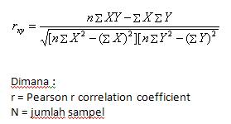

Uji Validitas

No. | Media Aplikasi | Keterangan
1. | Blogger | 2 Tidak Valid
2. | Wordpress | 2 Tidak Valid
3. | Edmodo | 1 Tidak Valid

Uji Reliabilitas
Variabel | r_{xy} | r_{tabel} | Keterangan
X1 | 0.635 | 0.423 | Reliabel
X2 | 0.645 | 0.423 | Reliabel
Y | 0.477 | 0.423 | Reliabel

Summary of Results Per Criteria Graphs QEM

Questionnaire Graph Results Per Media Web Application

Graph Results of Questionnaire Respondents

Analysis
Respondents Assessment Data Tabulation for Blogger
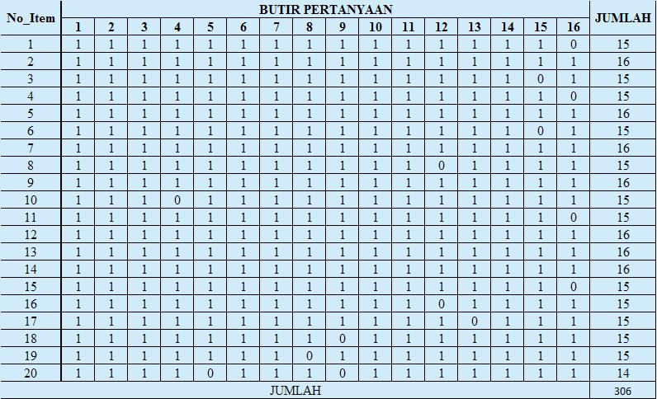

Respondents Assessment Data Tabulation for Wordpress
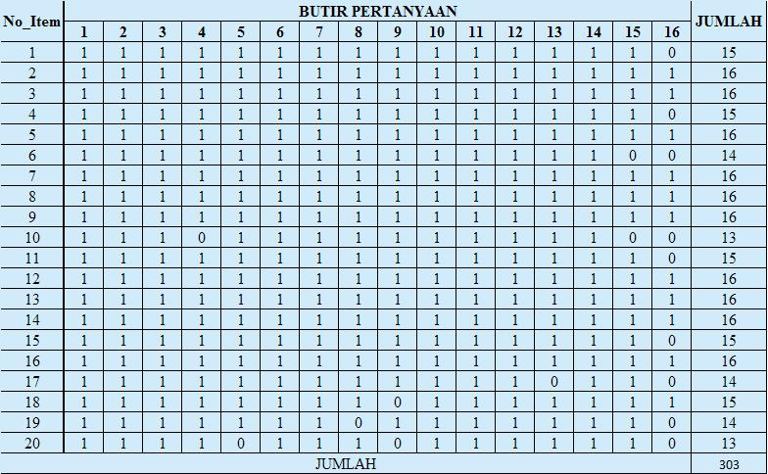

Respondents Assessment Data Tabulation for Edmodo
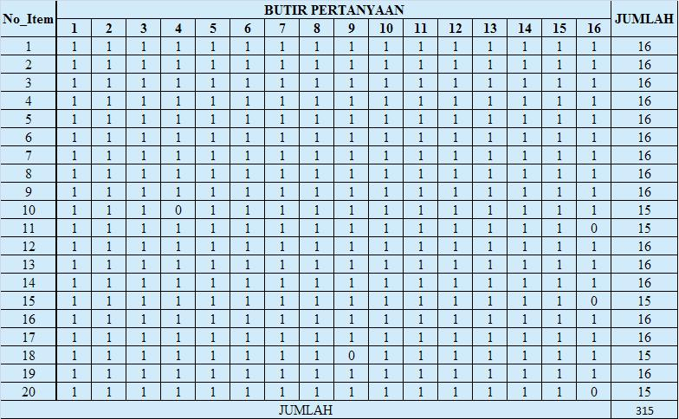

ISO 9126 Standards for Quality E-Learning Factor

Standar ISO 9126 | Media Aplikasi Web
 | Blogger | Wordpress | Edmodo
Funcional / Fungsional | √ | √ | √
Reliability / Keandalan | - | - | √
Usability / Kegunaan | √ | - | √
Efficiency / Efisien | √ | √ | √
Manitainability / Perawatan | √ | √ | √
Portability / Portabilitas | - | - | √
Hasil | 80% | 60% | 100%

The Conclusion
- From the results of the study involving respondents didapatlah media web application assessment results with the respondents' preferences for Edmodo value of 79.0, 77.75 and 75.5 for the blogger to wordpress. From the results of these respondents expected to help the Educational Technology course to be able to determine what media web applications that will be used to create e-learning systems in order bisaditerapkan on making college faculty and students in the course can understand the use of information technology (IT).
- The results of this study can also help Educational Technology courses in web applications determine what media will be used and applied in the program of study as well as in accordance with the wishes of students and faculty.

Suggestion
From the research that has been done and for researchers to do research, then researchers can gives advice that researchers suggest courses media web applications using Edmodo to be chosen as the medium used in making e-learning system that can be used by the program of study. This is because Edmodo has QEM criteria according to the standard models, namely in terms of accessibility or ease of access, in terms of speed or the speed of the site and access the content.

Bibliography
- Rusman dkk. 2011. Pembelajaran Berbasis Teknologi Informasi dan Komunikasi. Jakarta: Rajawali Pers.
- Wikipedia.org. 2013. Pembelajaran Elektronik, http://id.wikipedia.org/wiki/Pembelajaran_elektronik (diakses 9 Desember 2013)
- Effendi, Empy dan Zhuang, Hartono. 2005. E-learning, Konsep dan Aplikasi. Yogyakarta: Andi Offset.
- Sulistyandari. 2009. Cara Cepat Membuat Blog Menggunakan Wordpress. Surabaya : Tiara Aksa.
- W. Gulo. 2002. Metodologi Penelitian. Jakarta : PT. Grasindo.
- Prasetyo, Bambang dan Jannah, Lina Miftahul. 2012. Metode Penelitian Kuantitatif. Jakarta : Raja Grafindo Persada.

