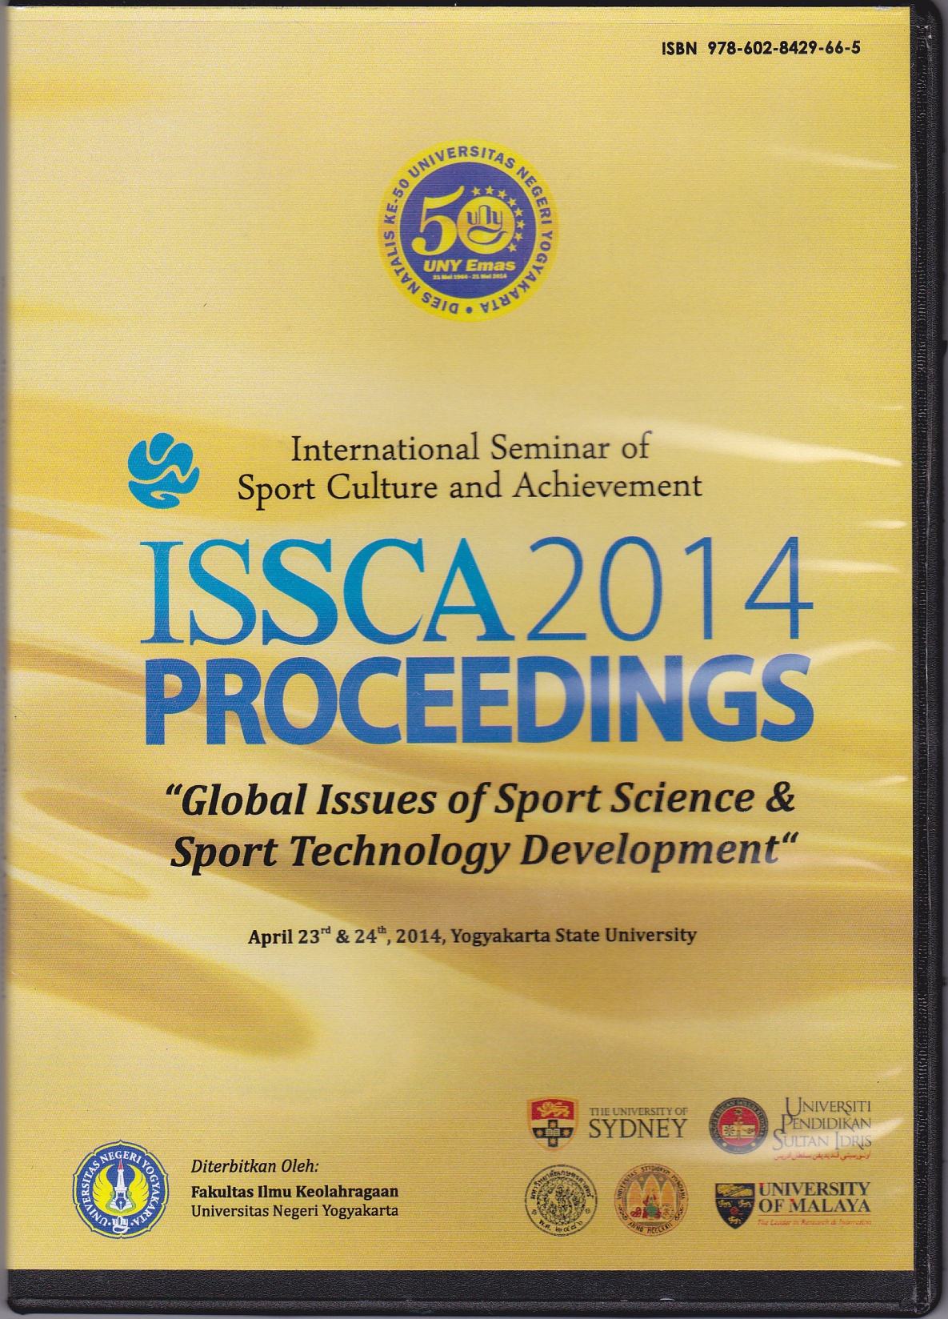

THE EFFECTS OF TRAINING AND ACHIVEMENT MOTIVATION ON VERTICAL JUMPING ABILITY

MUSLIMIN
BINA DARMA UNIVERSITY PALEMBANG

Abstract
Based on the field observations, it shows that jumping ability of male volleyball player in BinaDarma University Palembang still low.This research is purposed to find out the effects of training and achivement motivation on vertical jumping ability of male volleyball player at Bina Darma University. The type of this research is Quasy experiment. Population in this research is male student of Bina Darma University whose entering volleyball extracurricular and it is amounted to 84 persons. While, samples in this research, after divided into two groups that are high achievement motivation category (27%) and lower achievement motivation category (27%), are amounted to 44 persons. Instrument in this research is vertical leap test. Data were analyzed by two ways variant analysis technique. Results from the analysis indicating: (1) different result on vertical jumping ability between group with plyometric training method and weight training method, (2) interaction between training methods and achievement motivation on jumping ability, (3) in high achievement motivation category, groups with plyometric training method (A₁B₁) have better result than groups with weight training method (A₂B₁), and (4) in lower achievement motivation category, groups with weight training method (A₂B₂) have better result than groups with plyometric training method (A₁B₂).
Keywords: Training, Achievement Motivation, AbilitySkipVertical.
Preliminary
Sport is a human activity that can not be left out in everyday life . Sport has the goal of maintaining and improving health and fitness , achievement , human qualities , inculcate moral values ​​and noble character , sportsmanship , discipline , strengthen and nurture national unity , strengthen national resilience , as well as lifting the dignity and honor of the nation (Undang-undang No. 3 tahun 2005 tentang Sistem Keolahragaan Nasional).
One sport that is very popular in the community is a game of volleyball . Volleyball game was played the ball to the opponent through a barrier in the form of a rope or net and trying to win the game by turning the ball in the opponent ( M. Yunus , 1992:1 ) . Means playing a volleyball game / bouncing the ball before the ball falls or before the ball hits the floor . This game is a team game ( team ) . At the volleyball game , there are some basic techniques that must be mastered by people who would do this game is service , passing , bait , smash , weir / block . Of several techniques that volleyball game , to be able to execute it properly would have to be supported by good physical condition by the player .
Ideally , a volleyball player should have good basic technical ability , physical and mental condition in order to perform well . One is the physical condition of the players must have the ability to jump vertically . Players who have a good vertical jump ability , it will affect the smash technique or a good block . Due to smash that with perfect technique then it should be supported with a high vertical leap . Good physical condition is a key requirement for mastering technique and develop a skill sport . A speaker ( smasher ) in a volleyball game will not be able to hit the ball well and hard at the top of the net when the player does not yet have a high stepping strength , speed , and flexibility of the body is good . Likewise when doing a jumping service technique , a player must have the ability to skip vertical jump good to grab the ball from the highest point it throws then hit the ball towards the opponent's field , so it will be difficult for opposing players to do well passing . As the development of the current techniques , the player who has the ability to be profitable jumping service good for the team , because the service is the initial attack of the game .
Based on data from field observations , researchers found problems faced by volleyball players Universitas Bina Darma male Palembang is still low ability of vertical jump volleyball players Universitas Bina Darma 's son when doing a smash , jumping and block service . As a result of the lack of good players in performing the vertical jump , it will be able to affect the smash , jumping block. Someone service and volleyball players are required to have good vertical jumpto smash , block and jump serve . However, men's volleyball player of Bina Darma University Palembang not have the ability to jump high current smash , jumping service and block , because the volleyball game volleyball player , especially a player should be able to son over the net height of 2.43 m from the ground .
Based on the vertical jump test data volleyball player son of Bina Darma University Palembang is still a lot of players who have low. To vertical jump can do smash , and a good block and directional a player must be able to perform a high vertical leap , in order to pass through the net and passed block is performed by an opposing player . But in fact men's volleyball players in the field of Bina Darma Palembang frequent failure to smash . The failure is caused by the low ability vertical yang jump owned . Therefore, it will lead to a defeat for the team alone . Besides training program provided by the coach less than the maximum as well as the methods given too monotonous , so the players feel tired and less motivated to follow the training program given by the coach . So that will have an impact on the outcome of the exercise was not optimal .
One of the factors that support successful vertical jump is explosive leg muscle power . Explosive leg muscle power is one of the important components in activity sport biomotoric , because the explosive power will determine how hard the person is hit , how far throw , how high jumps , and how fast to run and is one of the important aspects of the physical condition of doing leap in doing vertical will jump smash or jumping service in volley ball games . To get the good exercise , proper training methods are needed . The ability of the coach becomes very important , knowledge and skills to be possessed , to the detailed things about the sport he coached . Heavy duty coach lies in the ability to design and develop appropriate strategies , how to spur his players to be totally involved in the preparation period training with the best .
To improve vertical jump can be done by using some form of exercise , which include plyometrics exercises and training burden . Practicing with plyometrics exercises is tantamount to a form of exercise plyometrics sports that require a high explosive movement . Many forms of plyometrics exercises are often used by coaches to improve vertical jump . Because plyometrics exercise is very effective for improving vertical jump ability players . Then, almost all movements in plyometrics exercises lead to movement in the vertical jump vertical jump ability to measure leg muscle which is owned by the player . Because in almost plyometrics training involves muscle movements of the body, and explosive movements are coordinated stepping movements with the arm swing both legs were very helpful to speed up the movement of the stepping motion that got explosive speed .Load-bearing exercises are exercises that use loads other than their own body weight as a tool to improve strength and speed .
Weight training exercise is any form of demands and characteristics of stimuli , both stimuli from inside or outside stimuli given to the athlete in a training process that can lead to the effect of exercise . Demands and stimuli are referred to in the form of demands and physical stimuli and may also be in the form of psychological stimulation ( mental ) . In addition to using the proper training , volleyball games can also be affected from the psychological aspect , because in a game that competed , psychological readiness factors also play an important role for the implementation of engineering skills in the game of volleyball . One of these is askpec achievement motivation . Achievement motivation is an athlete impetus owned in following sports volleyball training activities to achieve the feat . In this case the motivation is associated with seriousness and determination of athletes to exercise with diligence and passion . Conceptually berprestai athletes who have high motivation to have success in doing a better workout .Conversely , if a low motivation to training is feared to affect the results of the exercise are difficult to achieve.

Skip Essence Vertical.
Vertical jump is an act of the central body lift stand to gain up using leg muscle strength , which is a measure of how high a person is able to lift itself growing from the floor in a standing position . Skip vertical motion could also be interpreted as high jump with a focus on leg muscle strength to achieve stepping straight up to the maximum . Vertical jump is what is one of the critical success factors in the block and smash or jumping service . If a player can perform a high jump vertical, then the player will be able to smash when the ball is above the net , and can drive the ball as desired in order to pass block performed by opponent players. Faktor - factor that determines the vertical jump by Markworth in Syafruddin ( 2006:40 ) vertical jump ability depends on ( 1 ) muscle strength , ( 2 ) the role of muscle contraction speed , ( 3 ) the magnitude of the driven load , ( 4 ) inter-and intra- muscular coordination , (5) muscle length on when contraction and ( 6 ) the joint angle .
The Nature of PlyometricsTraining.
According to Chu ( 1996:81 ) defines plyometrics are specific exercises that train your muscles to produce maximum force more quickly . Maximum power is generated in a time that is unbelievably fast called explosive power or explosive power .Plyometrics exercises are exercises used to train the muscles to produce maximum power ( explosive power ) very quickly with the specific characteristics of muscle contraction which is very strong response of dynamic loading which is an important component for performance athletes . Most movements resulting from the reaction preceded by concentric and eccentric contractions of the opposite movement consetric can produce a high -speed movement . All training is done with the cycle pliomterik muscle lengthening ( eccentric ) and shortening ( concentric ) . The purpose of plyometrics exercise is one method to train in order to increase the explosive power that trained muscle . As is the case with other forms of exercise are other , plyometrics exercise also has the purpose of helping players to be able to develop the skills required at each power branch olahraga.Bentuk - form plyometrics exercises used in this study are as follows : 1 ) . Quick leap , 2 ) . Jump to box , 3 ) . Double leg stairbound , 4 ) . Single leg hops , 5 ) . Duble leg hops , and 6 ) . Lateral cone hops .
The Nature of Weight Training.
Weight training exercise is generally known as a form of exercise that uses external loads other than their own body weight like a barbell , dumbbell etc . According Harsono( 1988:185-186 ) method is overloaded training exercises in which the load is only used systematically as a tool to increase muscle strength achieve to certain destinations . The load-bearing exercise , if done right unless it can fix the overall physical condition , will also be able to develop speed , power , strength , and durability . The physical conditions are needed by an athlete to improve the interpretation of exercise .Various load-bearing exercises used in this study are : 1 ) Half Squat , 2 ) . Inverted leg presses , 3 ) . Dumble leg presses , 4 ) . Leg extension , 5 ) . Leg flexion and , 6 ) . Split squats .
The Nature of Achievement Motivation
Achievement motivation is an encouragement that is owned by someone , either boost that comes from within the person as well as encouragement from outside the person to be able to achieve the desired achievement . According Setyobroto ( 2001:24 ) revealed that achievement motivation is the desire , the desire , the will , and the driver to be able to excel , surpass that achievement ever achieved alone or achievements of others . Meanwhile, according Setiadarma ( 2000:73 ) " achievement motivation ( achievement motivation ) is the orientation of a person to keep trying to get the best results as possible with the basic ability to survive even fail and keep trying to do their best work , because he felt proud to be properly finish.

ResearchMethods
This research is a quasi experimental ( quasi -experimental 2x2 factorial with study design).
Table 2 x 2 factorial design
Achievement motivation | Training
 | Plyometric | Weight training
Hiegt | A₁B₁ | A₂B₁
Low | A₁B₂ | A₂B₂

The population in this study is that students who take part in coaching achievements totaling 127 sons and daughters . Sampling technique in this study is the use of purposive sampling technique that is based on sampling a particular consideration of the researcher . Based on this, the researchers determined the sample in this study group of 84 men's volleyball players . Based on the percentage techniques that total sample result of 44 people were divided into 4 groups of cells .After the division of the sample then the sample was treated as 16 sessions . Further tests carried out after the end of treatment was given to four groups , two groups of plyometrics exercises on high achievement motivation category ( A1B1 ) and low ( A1B2 ) , then the two groups for the training burden on high achievement motivation category ( A2B1 ) and low ( A2b2 ) given training in accordance with the designed program .
The data obtained will be processed by analysis of variance ( ANOVA ) followed by two lines and if found Tuckey test the interaction between variables training method with variable achievement motivation . Therefore, this study used a 2x2 factorial design , the data analysis using ANOVA technique two lanes , with a confidence level α = 0.05 . Before the data were processed using Analysis of Variance techniques , first tested the requirements of ANOVA , namely the normality test using the Test and Test of Homogeneity of Variances Liliefors using Bartlet test with significance level α = 0.05 .
Results and Discussion
Based on the results of the normality test calculations to eight groups over the study design was found that the price L obesrvasi ( Lo ) earned less than the price L tabel on the real level of 0.05 . It can be concluded that all groups of data in this study were drawn from a population that is normally distributed so that it can be used hypothesis testing research .Hypothesis testing of this research was done by using ANOVA two lanes . Further testing was then performed using Tuckey test . The use of two lanes ANOVA technique aims to determine the individual contribution of the independent variables on the experimental results (main effect) and to determine the effect of the interaction ( interaction effect) . The main effect in this study were ( 1 ) differences in the effect of plyometrics training methods and training methods berbeban terhadap vertical jump ability , and ( 2 ) the effect of the interaction is a combination of training methods and achievement motivation on vertical jump ability .
Based on the summary of the ANOVA calculations above two lines can be stated that : 1 ) the alternative hypothesis ( Ha ) states that there are differences in the effect of training methods between groups with plyometrics training methods and training methods acceptable burden , because the results of the calculations show that the F value = 4.84 > F = 4:05 . 2 ) the alternative hypothesis ( Ha) states that there is an interaction between training method and achievement motivation with the ability to jump vertically received , as the result of the calculation shows that F value = 41.33 > F = 4.05 .
With demonstrated research hypothesis which states that there are significant interactions and achievement motivation training methods need to proceed with the analysis Tuckey test . Summary Tuckey test results are presented in the table below:
Table Results of ANOVA with Test Tuckey Next Phase
Group compared | Dk | Q_{h} | Q_{t} (α = 0.05) | Ket
A₁dan A₂ | 1.05 | 3.11 | 2.92 | significantly
A₁B₁dan A₂B₁ | 1.49 | 8.63 | 3.77 | significantly
A₁B₂dan A₂B₂ | 1.49 | 4.23 | 3.77 | significantly
Based on the results of further trials using the Tuckey test can be stated that :
1 ) . The first research hypothesis stating that plyometrics training methods ( A1 ) results are more effective than the method of load-bearing exercise ( A2 ) is received . The mean score of group training methods A1 = 116.05 higher than the mean score training methods A2 = 112.77 ( Qh = 3:11 >Qt = 2.92).
2 ) . The third research hypothesis which states that the high achievement motivation training methods plyometrics ( A1B1 ) the result is more effective than exercise burden ( A2B1 ) is received . The mean score of the sample training methods A1B1 = 122.08 group was significantly higher than the mean score of group training methods A2B1 = 109.24 ( Qh = 8.63 > Qt = 3.77 ) .
3 ) . The fourth research hypothesis which states that the low achievement motivation , methods of group exercise training methods plyometrics ( A1B2 ) is lower than the results using the method of load-bearing exercise ( a2b2 ) is received . The mean score of the sample group training methods a2b2 = 116.30 higher than the mean score of group training methods A1B2 = 112.77 ( Qh = 4.23 > Qt = 3.77 ) .
Based on the data analysis of the first research hypothesis suggests that exercise pliomterik results are better than burden the exercise . The mean score of group training methods A1 = 116.05 higher than the mean score training methods A2 = 112.77 ( Qh = 3:11 > Qt = 2.92 ) .
The test results showed that exercise plyometrics hypothesis gives better results in improving vertical jump ability than weight training. Coz plyometrics movement characterized by the implementation of identical vertical jump .Where movements performed at high speed and maximum strength and muscle coordination arm contributed to skip to accelerate the movement of two legs. While the load-bearing exercises are exercises that are used to increase the strength and speed , if trained properly will produce endurance , and explosive power . Exercise dominant overloaded muscles locally trained , and the load used is external load other than its own body weight .Based on the data analysis of the second research hypothesis alternative hypothesis ( Ha) states that there is an interaction between training method and achievement motivation with the ability to jump vertically received , as the result of the calculation shows that F value = 41.33 > F = 4:05 .
The results of hypothesis testing to show that there are two methods of training and interaction between achievement motivation in improving vertical jump ability . Due to the implementation of the exercise requires good level achievement motivation . So that when the players practice implementation , the player can perform tasks with the spirit of the exercise movement . So from the results of the training process can players improve and achieve the desired achievement .
The third research hypothesis which states that the high achievement motivation training methods plyometrics ( A1B1 ) the result is more effective than exercise burden ( A2B1 ) is received . The mean score of the sample training methods A1B1 = 122.08 group was significantly higher than the mean score of group training methods A2B1 = 109.24 ( Qh = 8.63 > Qt = 3.77 ) .
Results of testing the third hypothesis states that the high achievement motivation category using plyometrics workout results are better than burden the exercise . Achievement motivation a player then the player will be able to carry a maximum plyometrics exercises, plyometrics exercise because the movements require high-speed and powerful . Thus a player who has high achievement motivation given category will receive training plyometrics training and obtain better results than the training burden .
The fourth research hypothesis which states that the low achievement motivation , methods of group exercise training methods plyometrics ( A1B2 ) is lower than the results using the method of load-bearing exercise ( a2b2 ) is received . The mean score of the sample group training methods a2b2 = 116.30 higher than the mean score of group training methods A1B2 = 112.77 ( Qh = 4.23 > Qt = 3.77 ) .
From the results of the fourth hypothesis states that the opposite occurs , the low achievement motivation category loaded exercise group were given a better result than the group given plyometrics exercises . Because the entire load-bearing exercises are not done with explosive movements , there is no coordination of all the muscles of the body , muscles trained local muscles , as well as the load applied external load other than its own body weight . So at the low achievement motivation fit berban use the exercise .Because it does not require a high motivation to perform exercise movements loading.
Conclusion
Based on the research findings and discussion of the research results can be summarized as follows :
1 . Influences of an increase in vertical jump ability between groups were given training and plyometrics exercise group given burden .
2 . There is interaction between training method and achievement motivation to increased vertical jump ability .
3 . At high achievement motivation category , exercise is more effective than exercise pliomterik burden to increase vertical jump ability .
4 . At low achievement motivation category , laden exercise is more effective than plyometrics exercises to increase vertical jump ability .
Suggestion
Based on the conclusions and implications of the above , are expected to :
1 .Trainer , in an effort to improve the ability vertikalpemain indispensable jump in volleyball game better , you should use a more precise method of exercise and good . In an effort to improve the vertical jump , the trainer can use plyometrics exercises and training burden .
2 . Player who has a high level of achievement motivation , using plyometrics exercises will provide improved vertical jump ability is very effective .
3 . Player who has a lower level of achievement motivation , using the training burden will have an effective impact on improving vertical jump ability .
REFERENCES
Chu, Donald A.1992. Jumping Into Plyometrics. Champaign, Illinois: Leisure Press.
Harsono. 1988. Coaching danAspek-aspekPsikologisDalam Coaching. Jakarta: P2LPTK.
Markworth, Peter. 1983. Spotmedizin. Hamburg: Rowohlt Taschenbuch Verlag GmbH.
M. Yunus. 1992. Olahraga Pilihan Bolavoli. Jakarta: Depdikbud.
Satiadarma, Monty P. 2000. Dasar-dasar Psikologi Olahraga. Jakarta: Pustaka Sinar Harapan.
Setyobroto, Sudibyo. 2001. Mental Training. Jakarta: Unit Percetakan Universitas Negeri jakarta.
Syafruddin. 2006. Pengaruh Metode Latihan Sirkuit dan Berat Badan Terhadap Daya Ledak Otot Tungkai. Disertasi: Jakarta.
Undang-udang RI Nomor 3 Tahun 2005 Tentang Sistem Keolahragaan Nasional. 2007. Biro HumasdanHukumKemenpora RI.

