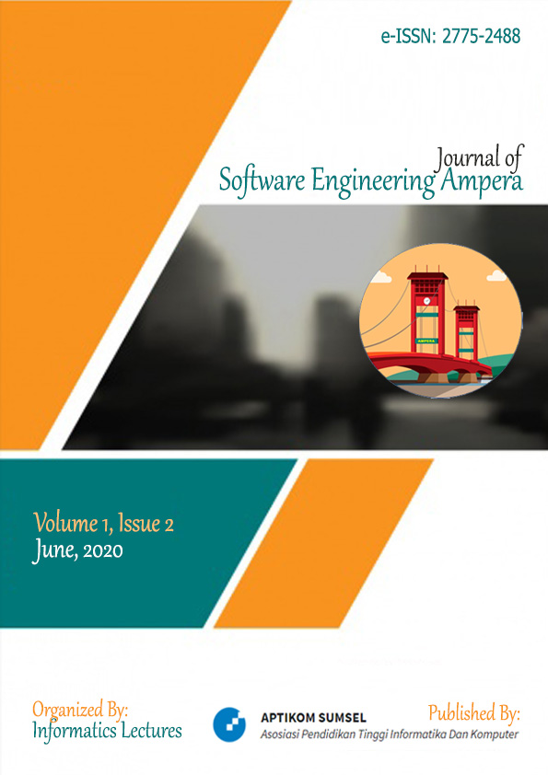

Vol. 1 No. 2 (2020): Journal of Software Engineering Ampera
Journal of Software Engineering Ampera (Journal-SEA) is organized and managed independently by the consortium of informatics lecturers. Journal-SEA is an open-access journal that is provided for researchers, lecturers, and students that published in Volume 1 Number 2 June 2020 Published 5 articles.
Published: 2020-05-25

Articles
- Analisis Pengaruh Perencanaan Strategis SI/TI Dalam Meningkatkan Upaya Keunggulan Bersaing
Cindyasri Pratidina Setyanti, Agustinus Fritz Wijaya
60-70
  - Download PDF
DOI : https://doi.org/10.51519/journalsea.v1i2.39
Abstract Views: 97 times | PDF Downloaded: 46 times | Published: 2020-05-25
- Implementasi Metode Klasifikasi Dengan Algoritma Support Vector Machine Untuk Menentukan Stok Persediaan Barang Pada Koperasi Karyawan Pangan Utama
Fadjar Pratama, Muhammad Nasir, Siti Sauda
71-81
  - Download PDF
DOI : https://doi.org/10.51519/journalsea.v1i2.46
Abstract Views: 37 times | PDF Downloaded: 14 times | Published: 2020-05-25
- Penerapan Algoritma Convolutional Neural Network Untuk Klasifikasi Motif Citra Batik Solo
Tungki Ari Bowo, Hadi Syaputra, Muhamad Akbar
82-96
  - Download PDF
DOI : https://doi.org/10.51519/journalsea.v1i2.47
Abstract Views: 67 times | PDF Downloaded: 42 times | Published: 2020-05-25
- Implementasi Data Mining Untuk Menentukan Pola Penyebab Kecelakaan Lalu Lintas Di Wilayah Kota Palembang Menggunakan Algoritma FP-Growth
Fathan Pangestu, Andri Andri
97-109
  - Download PDF
DOI : https://doi.org/10.51519/journalsea.v1i2.48
Abstract Views: 54 times | PDF Downloaded: 28 times | Published: 2020-05-25
- Penerapan Algoritma Knuth Morris Pratt Dalam Fitur Pencarian Pengarsipan Dokumen Pada Sma Plus Negeri 17 Palembang
Mohammad Ilham, Ahmad Haidar Mirza
110-121
  - Download PDF
DOI : https://doi.org/10.51519/journalsea.v1i2.49
Abstract Views: 55 times | PDF Downloaded: 58 times | Published: 2020-05-25

