ISSN 0216 – 0544
e-ISSN 2301 – 6914

PERSONALITY TEST SOFTWARE

aMerry Agustina, ^{b}Fatoni, ^{c} Mutiah Mawardah
a,b Faculty of Computer Sciene, Universitas Bina Darma
cFaculty of Psychology, Universitas Bina
E-Mail: merry_agst@binadarma.ac.id, fatoni@binadarma.ac.id, mutia_mawardah@binadarma.ac.id

Abstrak
Kepribadian merupakan sifat individual manusia, artinya tidak ada seorang pun yang memiliki kepribadian yang sama. Kepribadian bukanlah sesuatu yang salah ataubenar, bukan pula sesuatu yang baik atau buruk. Tiap jenis kepribadian memilikikelemahan dan kekuatannya sendiri. Kepribadian atau personality berasal dari kata persona yang berarti masker atau topeng, maksudnya apa yang tampak secara lahir tidak selalu menggambarkan yang sesungguhnya (dalam bathinnya). Hans Eysenck adalah nama tokoh Psikologi, yang mengembangkan empat pengukuran kepribadian salah satunya adalah Eysenck Personality Inventory (EPI). Tujuan penelitian ini adalah membangun software tes kepribaidan Eysenck (EPI) yang akan menghasilkan kepribadian individu yang dikelompokan menjadi dua kelompok yaitu ekstrovert dan introvert.
Kata kunci: Kepribadian, Eysenck Personality Inventory (EPI), Perangkat Lunak

Abstract
Personality is an individual human nature, meaning that no one has the same personality. Personality is not something wrong or right, nor is it something good or bad. Each type of personality has its own weaknesses and strengths. Personality or personality comes from the word persona which means mask or mask, meaning that what appears to be born does not always describe the real (in mind). Hans Eysenck is the name of the Psychologist, who developed four personality measurements, one of which is Eysenck Personality Inventory (EPI). The purpose of this research is to build Eysenck personality test software (EPI) which will produce individual personality which is grouped into two groups namely extrovert and introvert.
Keywords: Personality, Eysenck Personality Inventory (EPI), Software

INTRODUCTION

Everyone has a different personality from each other. Research on human personality has been done by experts since time immemorial. Measuring the personality of a person is basically aimed at knowing the personality traits in a certain and detailed. By knowing someone's style or personality type, our understanding of the person becomes more perfect, so that the educational process can be adjusted. Common personality traits are measured through self-reporting figures, personality questionnaires (for specific traits) or personality inventory, a set of instruments that uncover a number of traits.
Personality is an individual human nature, meaning that no one has the same personality. Personality is not something wrong or right, nor something good or bad. Each type of personality has its own weaknesses and strengths. Basically, everyday interaction is interaction. We will always pay attention and attention to others, for example, on a leader, he will be noticed and noticed by its members and vice versa [1]. According to Berry [4] in personality research, there are various terms such as motives, traits and temperaments that show a permanent distinction to the individual.
Personality test are a set of test tools designed to describe how a person's tendency behaves. To help explain personality, personality test kits use the help of numbers and then the results are interpreted / described qualitatively. Personality is unique, so it can not be compared with others in its description. However, in order to facilitate the measurement in psychology, a personality criterion is set up in the form of groupings.
Software is a collection of electronic data stored and regulated by the computer, electronic data stored by the computer can be a program or instruction that will run a command. The software is also called as a translator of commands that computer users run to be forwarded or processed by hardware. Through software or software this is a computer can run a command.
Software is a collection of electronic data stored and regulated by the computer, electronic data stored by the computer can be a program or instruction that will run a command. The software is also called as a translator of commands that computer users run to be forwarded or processed by hardware. Through software or software this is a computer can run a command.

H. J. Eysenck is a Psychology scientist born in Berlin, Germany in 1916. According to Eysenck, personality factors consist of three dimensions, among others 1) Extraversion (E) has nine traits, among others; friendly, dynamic, active, resolute, sensational, cheerful, dominant, rebellious, brave and Introversy is the opposite of extraversion, which is not social, quiet, passive, hesitant, thoughtful, sad, submissive, pessimistic and timid. 2) Neurotism (N) has nine trails, among others; anxiety, depression, feelings of guilt, low self-esteem, tension, irrationality, shyness, moodiness, and emotional. 3) Psychotic (P) has nine traits, among others, aggressive, cold, egocentric, unfriendly, inpulsive, antisocial, not empathetic, creative, and stubborn. Eysenck developed four personality measurements including Maudsley Personality Inventory (MPI), Eysenck Personality Inventory (EPI), Eysenck Personality Questionnaire (EPQ) and Eysenck Personality Questionnaire-Revised. [3].
In this study will be built software that can perform, process, and print the results of personality tests based on the scale of psychology EPI (Eysenck Personality Inventory). EPI (Eysenck Personality Inventory) is a standard Eysenck measuring tool, and is used for classifies individuals into two extroverted and introverted personality types.

LITERATURE REVIEW
Personality
Personality is an individual human nature, meaning that no one has the same personality. Personality is not something wrong or right, nor something good or bad. Each type of personality has its own weaknesses and strengths. Basically, everyday interaction is interaction. We will always pay attention and attention to others, for example, on a leader, he will be noticed and noticed by its members and vice versa[1].

Eysenck Personality Inventory (EPI)
EPI (Eysenck Personality Inventory) is a standard Eysenck measuring tool, and is used to classify individuals into two extroverted and introverted personality types. Number of question items in EPI of 57 questions. With details of 24 items of questions Extroversion (E), 24 items questions Neuroticism (N), and Lie (L) items 9 questions. This study takes all the questions to maximize the results of research.

Dimensions of Extrovert (E) and Neurotism (N) Eysenck, determine four quadrants (Wikipedia), as shown below:
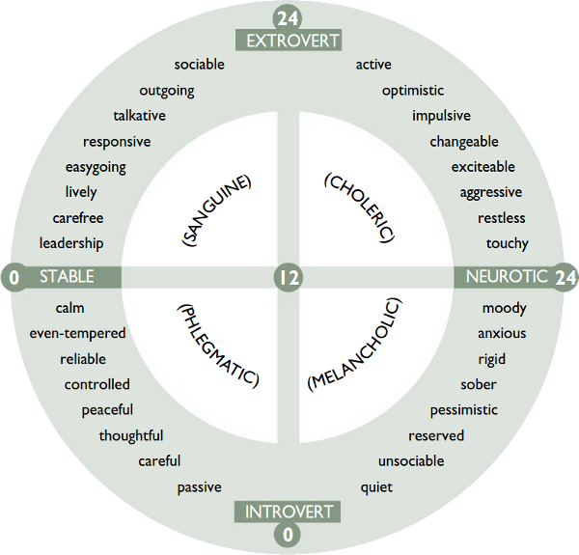

Figure 1. Eysenck Personality Inventory Graph
Software
According to a complete dictionary computer software program is a computer program created to work on or solve special problems.[5]

RESEARCH METHODOLOGY

Research Subject

The data needed as inputs or materials in this study are the types of human nature that make up the human personality itself, giving rise to different personality extensions. In this study is a software designed to perform, process, and print the results of personality tests based on the scale of psychology EPI (Eysenck Personality Inventory). EPI (Eysenck Personality Inventory) is a standard Eysenck measuring tool, and is used to classify individuals into two extroverted and introverted personality types.

Method of collecting data

Library Studies
This method is done by searching, reading and collecting data through documents in the form of books related to Eysenck personality tests, articles and literature on kerpibadian tests.

Interview Method
This method is done by conducting interviews or inquiring directly with the parties who can provide information about personality tests, such as personnel or HRS in the company and some psychological services bureau.

Browsing
This method is done by searching data and information relating to the material about personality test.

Software Development Method

Software development method used is SDLC model Water fall. According to Rosa A. S. and M. Saladin [3] explains that "the water-fall SDLC model is often also called a linear sequential linear or classic life cycle model." The waterfall model provides a sequential or sequential lifecycle approach starting from analysis, design, coding, testing and support or maintenance.

RESULT AND DISCUSSION

Software Requirement Analysis of Personality Test

Eysenck Personality Inventory (EPI)

The personality test software built as the goal of this study is based on the EPI (Eysenck Personality Inventory) EPI (Eysenck Personality Inventory) scale is a standard Eysenck measuring tool used to classify individuals into two extrovert personality types introvert The number of question items in the EPI is 57 questions With 24 items of questions Extroversion (E), 24 Question items Neuroticism (N), and Lie (L) 9 questions This research takes all questions to maximize research results.

Assessment and Scoring Test

Assessment and scoring test are based on existing rules, where each question item consists of 2 answers, "Yes" and "No". The answer matches the criteria (key) of Eysenck's personality test answers. Personaliy Inventory that already exist. If the answer matches or matches the answer criterion, then it is assigned a value of "1". If the answer is not the same as the answer criterion it is considered "0". Then the number of scale scales is matched to the norm and can be determined which extrovert and who are the introverted. Norms used in the classification of extroverted and introverted personality types based on the Eysenck Persoality Inventory test.

Design

Design is a continuation of the stages of analysis, at this stage detailed plans for the application is prepared so that the resulting software will run in accordance with the established goals, including design process logic, database and input and output interfaces.

Process Design

The design of the process describes the steps and sequences of the procedures of a program and the transpormation applied when the data moves from input to output.
The following use case diagram software personality test Eysenck.

Figure 2. Use Case Diagram

Table Design

The design of table structure is intended to facilitate in knowing what is contained in each data element. The table used in the making of this software consists of tables ci_sessions, epi_score tables, result tables, table tabel_user, table_role table, table menu, table_role table, option table, user table, and question table.

Menu Design

The design of the menu is the interface design choice of the choice of software to operate and facilitate the user in running the program. The design menu consists of admin menu and user menu.

Interface Design

Interface is the design of the form and menu that exist in the program and connected to the database so that the program runs well. In this software interface is divided into interfaces for admins and users. In each interface will also be divided into views for input and output.

Display Eysenck's Personality Inventory (EPI) Test

Following are the EPI Test views as a result of the design implementation that has been made.

Login Page

Figure 3. Login Page

As already explained that who can login on EPI test software is admin and test participants. For participants before login must register.

Admin Page

Admin is the actor who manages the software after login. The management yag can be done admin include language, questions and answers, epi score and results. Here's the admin page view.

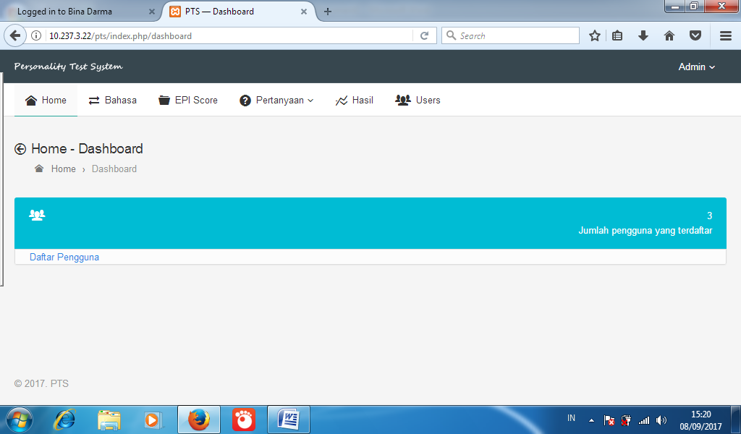

Figure 4. Admin Page

Registration Page

Registration page is an interface for users who will test by creating an account using email and password. Here's the menu view of the account.

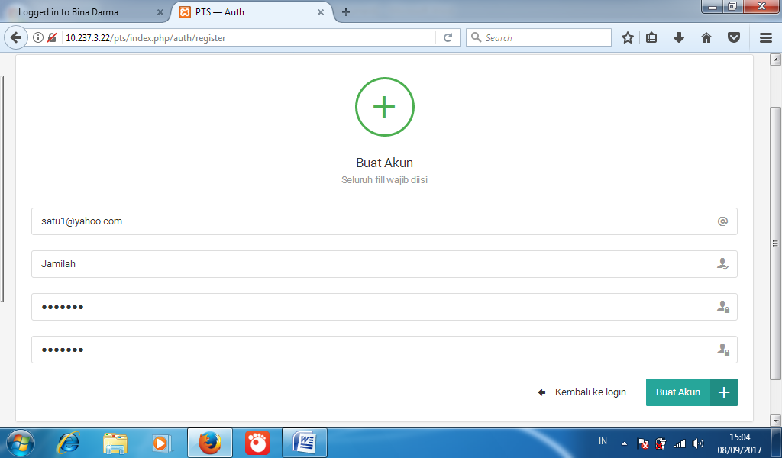

Figure 5. Registration Page

Test Page

For users who have registered by creating an account, then the user can do Eysenck personality test. Here is the test page view.

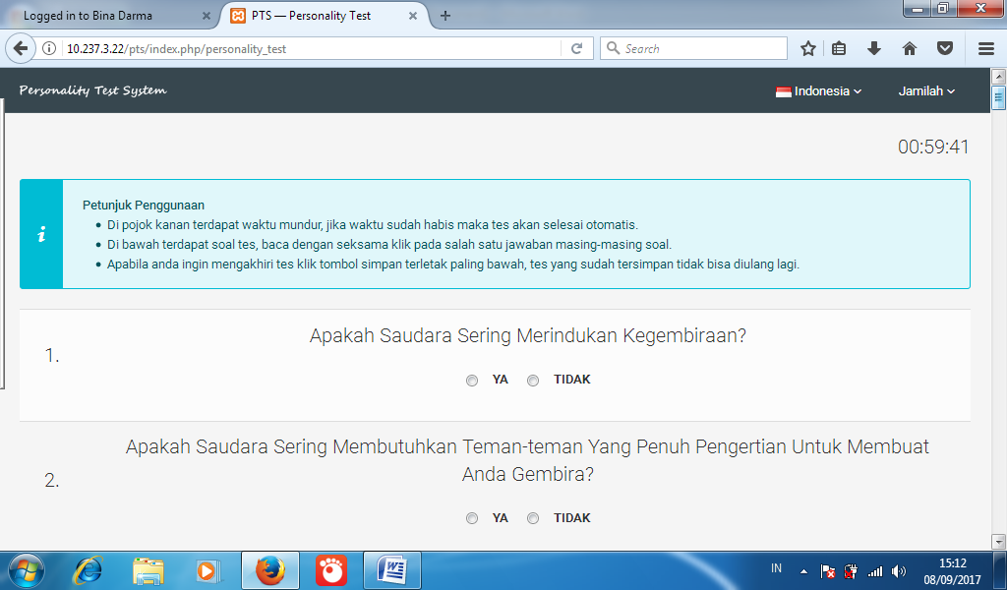

Figure 6. Test Page

Test Result Page

After Eysenck personality test with a maximum of 60 minutes, then the user can see the test results. Here's the display of test results.
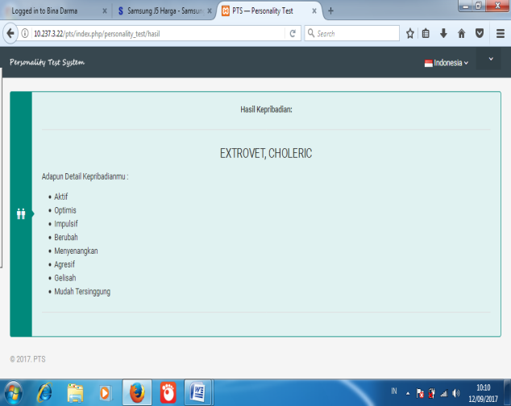

Figure 7. Test Result Page

CONCLUSION
Eysenck's personality test software built is an alternative media in the form of a standard Eysenck personality gauge, and is used to classify individuals into two extroverted and introverted personality types.

REFERENCES
[1] Budiman, I. (2009) Thesis. Application of
Personality Test Based Expert System Using
Visual Studio.Net 2008.

[2] Feist. J, & Feist. G. 2010.
Personality Theories, Book 2.
Jakarta: Salemba Humanika.

[3] Rosa U.S. and M. Saladin. 2013. Software
Engineering. Bandung: Informatics.

[4] Sobur. A, 2009. General Psychology.
Bandung: PT. Youth Rosdakarya

[5] Wahana Komputer, 2008,
Complete Dictionary of Computer World,
Andi, Yogyakarta

