The 5th ICIBA 2016, International Conference on
Information Technology and Engineering Application
Palembang-Indonesia, 19-20 February 2016

Characteristics of Users Website Kopertis II Palembang

Eka Hartati, Lin Yan Syah, Linda Atika

Postgraduate program, Bina Darma University
Jl Ahmad Yani No.3, Plaju, Palembang, Indonesia
e-mail: ekahartati90@gmail.com, linyansyah@gmail.com, lindaatika@binadarma.ac.id

Abstract

Kopertis Region II Palembang has a website address: http://www.kopertis2.or.id/. The website is use to display information about Kopertis Region II Palembang which can be accessed by the lecturer or an interested party. This study aims to determine characteristic of users Website Kopertis Region II Palembang using the usability and quality information. The factors of usability consists of Learnability, Efficiency, Memorability, Errors, Satisfaction, and quality information. The study was con- ducted using a questionnaire consisting of 263 respondents distributed via facebook and email.

Keywords : Website, Usability, Quality Information

1 INTRODUCTION

The breadth of information available and the increase is continuing, information providers should be able to provide constant and continuous information by utilizing information tech- nology support for the deployment, tracking, and access to information. Dissemination of information can be done to improve access and transfer of knowledge by using the media, one of them to build a website. Advance in the field of information technology into one of the prime movers birth of a website. The website as the one of example the usefull of technology.
Coordinating Education Higher Private is a government agency within the Ministry of Na- tional Education and the extension of the Directorate General of Higher Education Ministry of National Education in a particular area in order to carry out the supervision, control and guidance of the Private Universities (PTS) in the region. To expedite the process of communi- cation and information between Colleges particularly in Southern Sumatra, Kopertis Region II has a website address: http://www.kopertis2.or.id/.
The website is used to display information about Kopertis Region II Palembang which can be accessed by the lecturer or interested parties. Website Kopertis Region II Palembang have a link that consists of home page, profile, index, directory PTS, guest book, webmail, contact us, and the main page there is a speech from the coordinator Kopertis Region II Palembang. This study was conducted to determine the characteristics users of website Kopertis Region II Palembang by research method of usability and quality information. Usability is composed of five factors: learnability, effisiency, memorability, error and satisfaction. While the quality of the information consists only of the quality of the information.

2 RESEARCH METHODOLOGY

Population is the generalization region consisting of the object/objects that have certain qualities and characteristics that set the researcher to learn and then be deduced [1]. He number of respondents involved in this study were 263 respondents from population lecturer in Kopertis Region II Palembang. Method of primary data collection was conducted by questionnaire/questionnaire. Distributing questionnaires conducted for one month, starting from 5 November 2015 until December 5, 2015 conducted by directly to the user by using social media such as facebook and email.
According to Sugiyono [1] scale like used to measure attitudes, opinions and perceptions of a person or a group of social phenomenon which is a bipolar continuum scale, on the far left (lower figure) represents a negative answer. Being the tip of the right side (high numbers) represents a positive answer. Data on the dimensions of variables analyzed in this study were addressed to the respondents using a scale of 1 to 4 to obtain data that is ordinal and were scored as follows:

Table 1: Table Value
PK STS TS S ST

Value 1 2 3 4

Description:
PK = Question Questionnaire
STS = Strongly Disagree
TS = Disagree
S = Agree
ST = Strongly agree

Web is a hypertext facility that is capable of displaying data in the form of text, images, sound, animation and other multimedia, which among these data are related and connected to one another. The website is a repository of data and information based on specific topics. To access the website needs a web browser [2]. The website has various functions, namely the promotion of media, media marketing, media information, media education and media com- munication. Technology website continues to grow until popping the types of websites that diverse, namely portals, blogs, forums, multimedia, news, galleries, e-commerce, e-learning, social media and others. Website Kopertis Region II Palembang serves to provide information about Kopertis Region II, which can be accessed by lecturers and interested parties.
Usability is a quality attribute that shows how easily an interface is used. Consists of five components of quality, is a Learnability, Effisiency, Memorability, Error, Satisfaction [3]. From the definition already described, the testing in the study using the five aspects of usability or five attributes as proposed by [3].
The explanation of the five aspects are a: 1) Learnability. Explaining the size for the user in understanding a habit of visiting, knowing and identifying the reason access is sought. Indicators that affect this component are: easy to study the website of a system, quick to master the system to become proficient, the ease of using the system, it is easy to remember how to use the system and not get difficulty in its use, 2) Efficiency. Explaining that site

can efficiently provide information quickly. Indicators that influence is: How fast a task is done, do not take a long time to find the necessary, always succeeded in doing the task, can quickly improve if there is an error in its use, ease of access and quick in finding the desired information, 3) Memorability. Explaining the size for the user, the website will be easy to remember. If the website is changed, so visitors will need time to adjust and relearned. The component of indicator, namely: easy considering the process that has been done, can return to repeat the process that has been done, do not repeat the mistakes in the process, users can predict the outcome of a menu he chose, 4) Errors. Avoid links that do not work (broken link) or web pages that are still in the process of making. Indicators that affect namely: how many errors there are, there is a link that error, there is a clear message to the error link, there is a menu that does not respond and the system does not respond in accordance with what the user wants, 5) Satisfaction. How is a thing most desired by each user. Visitors of the site wants can be easily used and studied. In addition they want to find what they need quickly, knowing where they are and can go anywhere within a site. Indicators of this component are: The desire to re-visit the website, satisfaction with the available information, the system gives the user an appropriate response to the desire, the desire to recommend use web site to others and satisfaction with the system, and 6) Quality of Information. Quality is a dynamic condition related to products, services, people, processes and environments that meet or exceed expectations. Indicators of these components, namely: the accuracy of an information, information updates, relevant information, detailed information, and information that is simple and easy to understand Kanishka dan Hepu [4]. Given these premises, the authors create a framework as follows:

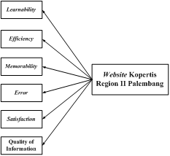

Figure 1: Framework

3 RESULTS AND DISCUSSIONS

3.1 Respondents Description

Data from the study conducted on 263 respondents can be stated characteristics of re- spondents by sex can be seen in Figure 2.

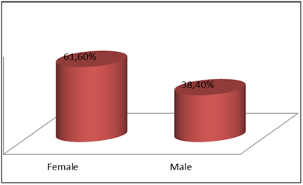

Figure 2: Characteristics of respondents by gender of respondents.

Characteristics of respondents by gender shows, gender of the largest to the questionnaires were men as much as 61.60% and the smallest with female sex as much as 38.40%.
Characteristics of respondents by level of education can be seen in Figure 3.

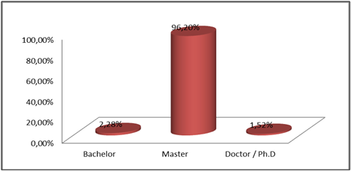

Figure 3: Characteristics of respondents by education level of respondents

Characteristics of respondents by level of education determines the level of education the largest for filling out the questionnaire is the Master as much as 96.20% and the smallest level of education Doctor / P.hD as much as 1.52%.
Characteristics of respondents by faculty origin can be seen in Figure 4.
Characteristics of respondents by faculty shows the origin, the origin of the largest faculty for filling out the questionnaire is the faculty of the computer as much as 64% and the smallest with non computer faculty as much as 36%.

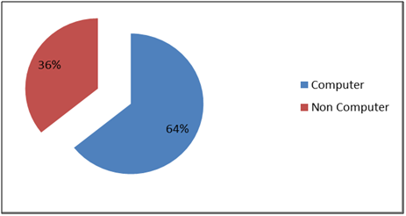

Figure 4: Characteristics of respondents based on the origin of the faculty respondents

Based on the findings of the data that has been obtained through questionnaires to 263 respondents, the results obtained aspects of usability and quality of information in Table 2 as follows:

Table 2: Results Aspects of Usability and Quality Information
No | Variable | Strongly Disagree | Criteri  Disagree | a  Agree | Strongly agree
1 | Learnability | 0,38% | 10,65% | 43,16% | 45,82%
2 | Efficiency | 0,00% | 7,03% | 35,17% | 57,79%
3 | Memorability | 0,19% | 21,20% | 52,00% | 26,62%
4 | Error | 6,75% | 37,45% | 23,48% | 32,32%
5 | Satisfaction | 0,19% | 9,89% | 53,80% | 36,12%
6 | Quality Information | 0,00% | 2,95% | 40,30% | 56,75%

Table 2 show the results of usability aspects and quality of information which can be explained as follows: 1) In the variable learnability most respondents chose not agree at
45.82%, it indicates the user’s perception of the website Kopertis Region II could not agree to be ease of use, 2) In the variable efficiency respondents most choose not agree at 57.79%, it indicates the user’s perception of the website Kopertis Region II strongly agreed the website will be efficient in use, 3) In the variable memorability most respondents voted in favor of
52.00%, this shows the user’s perception of the website Kopertis Region II agreed to ease given the processes in use, 4) In the error variables most respondents chose not agree at
37.45%, it indicates the user’s perception of the website Kopertis Region II disagree on the website still has an error in the website, 5) In the variable most satisfaction of respondents voted in favor of 53.80%, this will show disapproval of the website user satisfaction Kopertis Region II, and 6) In the variable quality of information most respondents chose not agree at
56.75%, it indicates the user’s perception of the website Kopertis Region II strongly agree will the website still has the quality of information in the website.

4 CONCLUSIONS

Based on the research that has been done, it can be concluded that:

1. Characteristics of the website Kopertis II Palembang region consists of lecturers, the gender male, education level and the master comes from faculty computers.

2. The results of the usability aspects and the quality of the information indicates that the user of the website Kopertis Region II Palembang agreed to ease of use, efficient, easy to remember processes in use, satisfaction in the use and quality information and do not agree on such websites still have errors in in the website.

References

[1] Sugiyono, Metode Penelitian Pendidikan Pendekatan Kuantitatif, Kualitatif dan R&D.
Bandung: Alfabeta, 2010.

[2] S. Riyanto, Membangun Website dengan Adobe Photoshop dan Macromedia Dreamweaver, Penerbit Datakom Lintas Buana, Jakarta, 2007.

[3] J. Nielsen, Guerrilla HCI: Using discount usability engineering to penetrate the intimida- tion barrier, Cost-justifying usability, pp. 245-272, 1994.

[4] K. Karunasena, H. Deng, Critical factors for evaluating the public value of e-government in Sri Lanka, Government Information Quarterly, vol. 29, pp. 76-84, 2012.

[]

