The influence of climate change on the water fluctuations in the sekanak river of Palembang city

A Syarifudin

Department of civil and environmental engineering faculty, Universitas Bina Darma, Jalan Jend. A. Yani No. 3 Palembang (30264), Indonesia

[Syarifachmad6080@yahoo.co.id](mailto:Syarifachmad6080@yahoo.co.id)

**Abstract.** Floods during the rainy season has become routine events in several cities in Indonesia. Various reasons to trigger the occurrence of flooding, among other drainage network system capacity is decreased, increasing water flow, or a combination of both. The capacity of the drainage channel has been calculated based on the design criteria to accommodate the flow of water occurs so that the area is not experiencing inundation or flooding. The reduced system capacity due to, among others, many precipitates, physical damage or their network systems and illegal buildings on the system network. While the cause of the discharge increases, among others, high rainfall out of habit, changes in land-use, environmental damage to the basin in a region.

Cases like mentioned above also occur in Sekanak Sub-basin, so it is necessary to study the drainage network performance evaluation system based on the concept of sustainable drainage based on community participation. One technical aspect is the frequency analysis to look at the picture unit hydrograph. Analytical results from this study may be that the maximum flow of 25 m3/sec at peak hours at the time of 4.8 hours and then slowly starting to go down at a time to 24 hours.

Due to climate change impact on the water level at the mouth of the Musi river by 0.20 – 0.40 meters. Thin will also have an impact on the change of water level in the mouth of the Sekanak river. The total depth of water occurs at 15-30 meters and therefore contributes to the flow of the water fluctuation from Musi river to the Sekanak river.

1. Introduction

At certain times during the rainy season is often an increase in the flow rate, or there has been increased discharge caused by various reasons, the capacity of the existing system can no longer accommodate the flow rates, resulting in flooding in a region. While the cause of the increased discharge include high rainfall out of habit, changes in land use, environmental damage to the basin in a region. Then if an urban or regional decrease system capacity at the same time an increase in the flow rate, the flooding is increasing, both the frequency, extent, depth and duration. [1]

The flood disaster became a regular phenomenon in the rainy season which is spread in different basin in most parts of Indonesia. Total incidence of flooding in the rainy season over the last 3 years as well as the increasing number of human casualties and loss of property and facilities from public/social, transport infrastructure and infrastructure for agriculture / irrigation. In addition to the problem of precipitation as factors, the incidence of disasters can not to be separated from environmental damages to ecosystems that occur in the basin and poor management of water resources. Their land damage leading to increased surface run-off coefficient greater. The area upstream basin is an area of ​​a particle will be increasingly vulnerable to drought, precisely the opposite downstream areas prone to flooding. Flooding is a flow that caused economic losses or even cause loss of life. [2]

Flow can occur because of the outburst in the area in the right or left of the river due to river channel does not have enough capacity for the flow rates through. Flooding is not only experienced by urban area located in the lowlands, even experienced area located in the highlands. Flooding or inundation in a region occurs when the system that serves to accommodate the inundation was not able to accommodate the discharge flow, it is the result of three possibilities occur: the capacity of the system to decrease the flow rate of water increases, or a combination of both. Understanding the system here is a system of drainage network in a region. [3]

While the drainage system can be generally defined as a series of waterworks that serve to reduce and / or remove excess water (flooding) of a region or land, so the land can function optimally, so the drainage system is an engineering infrastructure of the region to cope with the inundation floods. Drainage network system in a region already properly designed to accommodate for normal flow rates, especially during the rainy season. This means that the capacity of the drainage channel is already taken into account to accommodate the flow of water occurs so that the area is not experiencing inundation or flooding. If the capacity of a drainage channel system decreases due to various reasons, the normal discharge could not be accommodated by the existing system. While declining because drainage capacity, among others, there are many deposition, physical damage tissue system, the other buildings on top of the network system. [4]

This means that the capacity of the drainage channel is already taken into account to accommodate the flow of water occurs so that the area is not experiencing inundation or flooding. If the capacity of a drainage channel system decreases due to various reasons, the normal discharge even can not be accommodated by the existing system. While declining because drainage capacity, among others, there are many deposition, physical damage tissue system, the other buildings on top of the network system. At certain times during the rainy season is often an increase in the flow rate, or there has been increased discharge caused by various reasons, the capacity of the existing system can no longer accommodate the flow rates, resulting in flooding in a region. While the cause of the increasing discharge including high rainfall out of habit, changes in land use, environmental damage to the basin in a region. [5]

1. Methods
   1. *Location Research*

## The location research is Sekanak sub-basin. The research location as in figure 1. (Figure 1. Map of the research location). [6]

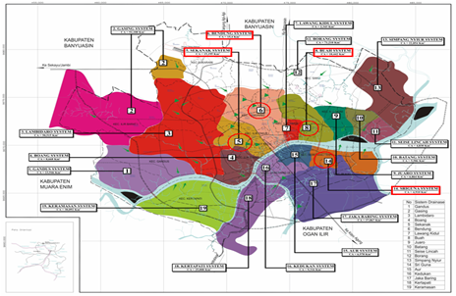

**Figure.1**. Research location

* 1. *Tools and material*

The tools will be used in this study are shown in Table 1.

Table 1. list of the tools used in the study

|  |  |  |  |
| --- | --- | --- | --- |
| No. | Name tools | Number of uses | Description |
| 1 | Stationery | 1 box | Data recording |
| 2 | Computer (RAM 2 GB) | 1 unit | General perform model |
| 3 | Printer | 1 unit | Display report form |
| 4 | Software GIS, Arc-View, MIKE-21, MS-Excel | 1 piece | To perform modelling and data processing |
| 5 | Laptop and Printer | 1 unit | Assist in preparing report |

* 1. *Rainfall data*

Rainfall data used for 23 years, from 1991 through 2013. The data attached to the rainfall data hourly. Rainfall data can be seen in Table 2.

**Table 2.** Short-term data maximum rainfall

|  |  |  |  |
| --- | --- | --- | --- |
| Years | Duration  60 minute | Years | Duration  60 minute |
| 1991 | 73.50 | 2003 | 71.50 |
| 1992 | 80.10 | 2004 | 80.00 |
| 1993 | 55.70 | 2005 | 91.90 |
| 1994 | 48.50 | 2006 | 60.90 |
| 1995 | 60.00 | 2007 | 65.00 |
| 1996 | 47.20 | 2008 | 86.00 |
| 1997 | 91.80 | 2009 | 79.50 |
| 1998 | 52.30 | 2010 | 90.00 |
| 1999 | 73.50 | 2011 | 80.00 |
| 2000 | 70.40 | 2012 | 86.93 |
| 2001 | 77.00 | 2013 | 77.63 |
| 2002 | 60.90 |  |  |

**Table 3** Rainfall intencity

|  |  |  |  |
| --- | --- | --- | --- |
| Years | Intencity  (mm/hours) | Years | Intencity  (mm/hours) |
| 1991 | 73.50 | 2003 | 71.50 |
| 1992 | 80.10 | 2004 | 80.00 |
| 1993 | 55.70 | 2005 | 91.90 |
| 1994 | 48.50 | 2006 | 60.90 |
| 1995 | 60.00 | 2007 | 65.00 |
| 1996 | 47.20 | 2008 | 86.00 |
| 1997 | 91.80 | 2009 | 79.50 |
| 1998 | 52.30 | 2010 | 90.00 |
| 1999 | 73.50 | 2011 | 80.00 |
| 2000 | 70.40 | 2012 | 86.93 |
| 2001 | 77.00 | 2013 | 77.63 |
| 2002 | 60.90 |  |  |

1. Result and Discussion
   1. *Sekanak sub-basin*

Determination of flood discharge plan to do with Synthetic Unit Hydrograph method (Synthetic unit hydrograph) Nakayasu. Before entering in the calculation of the discharge plan using Synthetic Unit Hydrograph Method Nakayasu data are necessary length of the Sekanak river and Sekanak sub-basin area. Sekanak sub-basin is divided into sub-sub-basins with the help of Global Mapper program. Sekanak sub-basin can be seen in figure 2. [7]

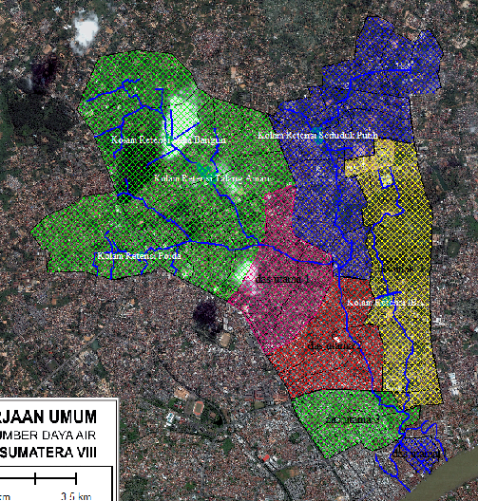

**Figure. 2.** Distribution of Sekanak sub-basin with Global Mapper

* 1. *Frequency Analysis*

Before analyzing rainfall distribution, first determine the parameters of existing statistics. Then calculate the total amount, the amount of data (n), the maximum data Ri average, standard deviation (S), Coeffisien of Variation (Cv), Coeffisien of Skewness (Cs), and Coeffisien of kurtosis (Ck).

The result of the calculation as follows:

1. Total amount = 1660.26 mm / hour
2. Total rainfall data, n = 23
3. On average Ri = 72.18 mm / h
4. The standard deviation (S) = 13.66
5. Coeffisien of Variation (Cv) = 0.19
6. Coeffisien of Skewness (Cs) = -0.34
7. Coeffisien of kurtosis (Ck) = -0.90
   1. *Rainfall Intencity*

The intensity of rainfall that used is the rainfall intensity data from the calculation of the Normal Distribution.

**Table 4** Rainfall intencity

|  |  |
| --- | --- |
| R (Year) | XT (mm/hours) |
| 2 | 72.18 |
| 5 | 83.66 |
| 10 | 89.67 |
| 20 | 94.59 |
| 50 | 100.19 |
| 100 | 104.01 |

Period re-elected for further calculations that the return period of 2 years.

* 1. *Run-off Coefficient*

Run-off coefficient reflects the state of the surface flow area. Drainage coefficient, C is the ratio of the volume of water that reached the mouth of the river basin with the volume of water that fell on the watershed. Value for drainage coefficient, C can be seen in Table 5.

Data obtained from Bappeda of Palembang city, extensive land use for residential areas are:

Size high density = 7.09 km2

Extensive catchment area = ​​7.37 km2

Comprehensive trade area = 4.73 km2

Based on the flow coefficient table 5 for residential areas with a high density area and retrieved 0.70 to 0.20 wide catchment areas taken as well as to extensive trade area taken 0.90. Then the value C: runoff coefficient values ​​obtained, C = 0.56 and in the calculation taken C = 0.60.

**Table 5** Run-off Coefficient

|  |  |  |
| --- | --- | --- |
| Region | Land use | C |
| Urban  Rural | Rural Settlement Region:  - Low density  - Middle density  - High density  - With wells impregnation  Trade zone  Industry region  Parks, green lanes, gardens, etc.  Hills, slopes < 20 percent  Canyons region, the slope of > 20 percent  Land with terracing Rice fields | 0,25-0,40  0,40-0,70  0,70-0,80  0,20-0,30  0,90-0,95  0,80-0,90  0,20-0,30  0,40-0,60  0,50-0,60  0,25-0,35  0,45-0,55 |

*3.5. Mike-21 flow model Simulation*

MIKE-21 Hydrodynamic Module (HD Module) is a mathematical model to calculate the hydrodynamic behavior of the water against a wide variety of styles functions. Particular wind conditions and water levels are specified in the open model of the boundary. HD module simulates the water level and the current differences in the various styles function in lakes, estuaries, and beaches [8]



**Figure 3.** Velocity direction in Musi river

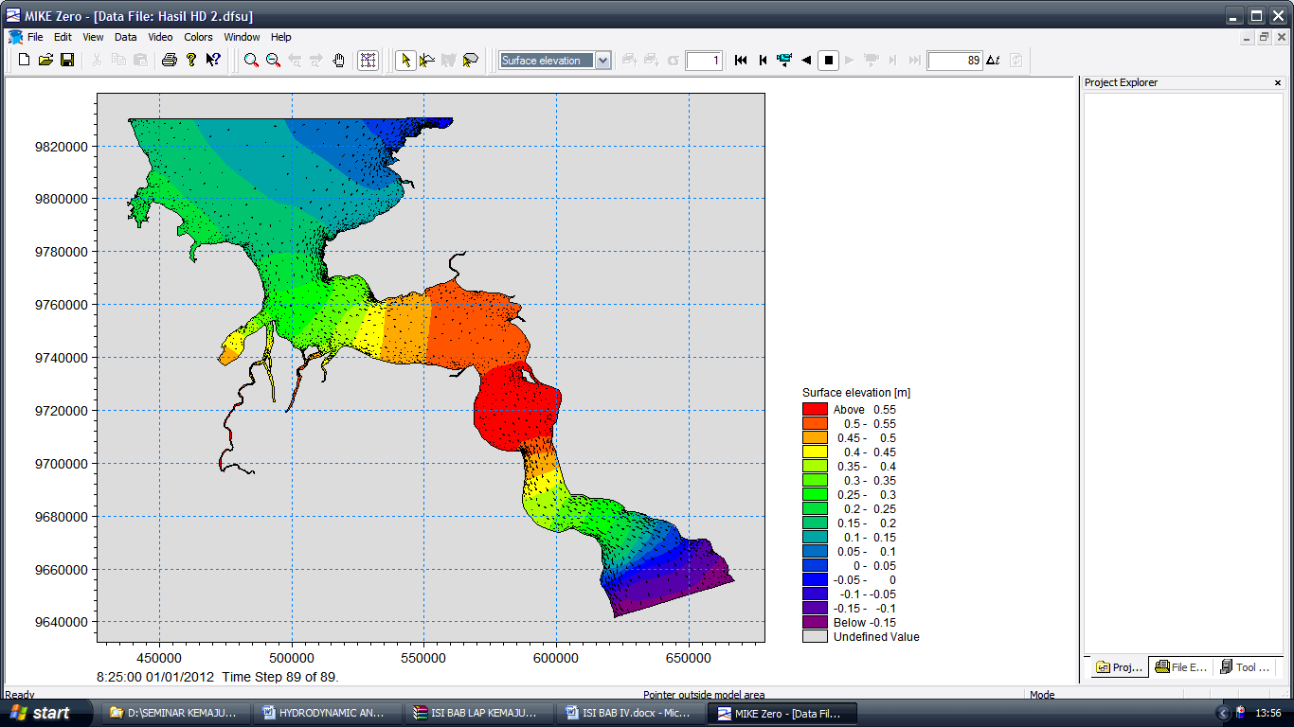

**Figure 4.** Water elevation on Musi River

1. Conclusions

Cases like mentioned above also occur in Sekanak sub-basin, so it is necessary to study the drainage network performance evaluation system based on the concept of sustainable drainage based on community participation. Drainage system performance can be evaluated from the technical aspects as well as non-technical. One technical aspect is the frequency analysis to look at the figure of unit hydrograph. Analytical results from this study may be that the maximum flow of 25 m3/sec at peak hours at the time of 4.8 hours and then slowly starting to go down at a time to 24 hours.

Due to climate change impact on the water level at the mouth of the Musi river by 0.20 – 0.40 meters. This will also have an impact on the change of water level in the mouth of the Sekanak river. The total depth of water occurs at 15-30 meters and therefore contributes to the flow of the water fluctuation from Musi river to the Sekanak river.

References

1. Asdak S 2004 *Hydrology and Watershed Management Area* (Gadjah Mada University Press) pp
2. Syarifudin A 2017 *Applied Hydrology* (Andi Publishing Company) pp
3. Syarifudin A 2017 *Environmentally Urban Drainage* (Andi Publishing Company) pp
4. Suripin 2004 *Sustainable of Urban Drainage System* (Andi Publishing Company) pp .......
5. Cahyono M 2001 *Biogeographic Hydraulic and Water Quality of Rivers* (ITB Bandung) pp
6. A. Syarifudin. The 2nd International Conference on Informatics, Environment, Energy and

Applications (IEEA 2013), Bali, Indonesia, March 16-17, 2013, JOCET (Journal of Clean Energy

and Technology) Journal ISSN: 1793-821X Vol. **2**, No. 1, January 2014. (2013)

1. A. Syarifudin, 5th ICIBA International conference on information technology & Engineering Application, Palembang (2015)
2. A Syarifudin “The influence of Musi River Sedimentation to The Aquatic Environment” <https://doi.org/10.1051/matecconf/201710104026>Volume 101 (2017) MATEC Web Conf, 101(2017)04026 [published online 09 March 2017]
3. Wanshun Zhang, Yanhong Xu, Yanru Wang, and Hong Peng “Modeling Sediment Transport and River Bed Evolution in River System” Journal of Clean Energy Technologies, Vol. 2, No. 2, April 2014
4. Reini Silvia. I. Study Of Sediment Transport At Musi River In Front Of Fort Kuto Besak Palembang, Proceedings HEDS-SST, HEDS Forum, Jakarta 2006
5. Jessica Pineda Z. 2005, "Maintenance of river ecosystems within urban areas", thesis, International Institute for Geoinformation Science and Earth Observaion Enschede, Urban Planning and Land A dministration, Netherlands.
6. Robert. J. Kodoatie, Sugiyanto, 2002, "Flood causes and methods of control in an environmental perspective.", Yogyakarta
7. C Leo Van Rijn. Principles of Fluid Flow and Surface Waves in River, Estuaries, Seas and Ocean, Aqua Publications Nederlands 1990.
8. Marfai, Muh. Aris, 2003, GIS Modeling of River and Tidal Flood Hazards in a Waterfront City, M. Sc Thesis, ITC Enschede, The Netherlands.