INTERNET SHOPPING BEHAVIOR OF INDONESIAN YOUNG AGE CUSTOMERS
(A QUALITATIVE APPROACH ON COMMUNICATION STUDENTS OF UNIVERSITY BINA DARMA)

Ema Apriyani

University of Bina Darma Palembang, Jl. Jend. A.Yani. No. 12 Plaju Palembang 30264, Indonesia

kindaichiema@gmail.com ; ema.apriyani@binadarma.ac.id

ABSTRACT

While people lives in information and technology era, the use of internet in the society daily life are highly increase. Online shopping has become a daily activity for most of urban people, especially in developing countries like Indonesia. There are limited studies belong to investigate cognitive factors influencing individuals’ internet shopping behavior in Indonesia, especially focusing in the young age shopping behavior. This study aims to answer the problem by using widely used socio-psychology based theory the Technology Acceptance Model (e-TAM). This theory will be abstracted to the online shopping context open questions for conducting focus group discussion. The results will gives a basic insight about internet shopping behavior for an Indonesian young age sample. At the end, the result is aim to discover the significant theoretical insight and gathering the core problems about internet shopping behavior of Indonesian young age customers for advance research in the future.

Key words: e-commerce, young ages, Focus Group Discussion, Online Shopping, Indonesia

INTRODUCTION
Along with the growth of technology in information and communication area, there are significant changes in the society. Back to the 1990s, when the internet comes as phenomena among the citizen, people start to have a new habits, related to online world. Personal computer and or laptop become more popular. Phone is not only communication tools; it has more function to answer the need to be connected to the internet. Recently, people use their phones or gadgets to have the mobile internet connection.
Since the first, internet has become a very complicated yet profitable business. It has business inside business. Now, we can use internet to build our own business, make our own market by selling products or trade it. Coupled with the changes, traditional of “buying-selling” transaction on the society have also altered. The new concept of shopping is emerged and spread widely among internet users. Nowadays, we call it “Online Shopping”.
More and more people get used to the internet lead to the increasing of the online shopping users. Not only the seller, or the buyers but also the web developers and people behind that service also growing rapidly. Interact with the internet, especially in the shopping case, is interesting questionable experience. To answer the curiosity this research was conduct with involving young age’s consumer as a representation of the 2.0 generation or online generation.
Developing country such as Indonesia will be the interesting object to be explored related to this issue. Some of the reasons are because in the developing countries, the behaviors of the people in any circumstances are unique. The varieties of their personal background, education, culture and others factors are very wide. Moreover, the research for this kind of issue, especially in Indonesia is still rarely. The aim of this research is to gather the basic problems of internet shopping behavior in Indonesia. The long goal for this research is to lead another researcher to have a research in this field.

II. MATERIAL AND METHOD
Internet in Indonesia
Indonesia is an archipelago country with the range of area almost 2 million km2. Indonesia geographical characteristics is consist 17,508 islands, 33 provinces with 476 municipal or regency and 62,806 villages. As the largest archipelago country in worldwide, the population of Indonesia citizen nowadays is among 237 million people with annual economic growth of 4% per year. In general Indonesia people characteristics have almost equal balance of gender, with the labour force of 94 million and farmer as majority occupation all around Indonesia.
Beside has a national language, Indonesia’s is still using their own local language as a second language; they have 583 different dialects across the country. Indonesia citizen 66% is in productive age, or dominated by the age 15 to 49 years. Supporting this fact, it will be interesting to have an insight to the online shopping behaviours Indonesia citizen who is on the young ages.
In Indonesia, internet users grow rapidly each year. By the year of 2000 the internet user was only 2.000.000, eight years later (2008) the number increase more than 120% to 25.000.000 people. This number was representation about 10% populations from Indonesia citizen.
By the year of 2010, 45 million Indonesia people have becomes internet user. Personal computer ownership in Indonesia on 2009 was 8, 32% from the total citizens. This significant growth is supported by the increase of free hotspot all around Indonesia and the “internet villages 2010” program’s from government. Not to mention the technology devices market in Indonesia, which is the most profitable area in Southeast Asia.
Another fact related to the online world in Indonesia is, Indonesia is on six (6) rank of cellular or mobile phone user worldwide. In 2006, the cellular users were 63.803.000, one year later in 2007 the number increase significantly to 96.405.000, and in 2008 the cellular phone users in Indonesia reached 131.144.392 users. We can assume that cellular phone users in Indonesia are growth 38% each year. By all these fact, there is a very massive movement in the technology use and acceptance among Indonesian citizen [1].

Indonesia and e-Commerce
E-commerce is an internet service that has been use for selling-buying transaction. E-commerce changes the old traditional of shopping culture. By using e-commerce people does not have to meet to sell or buy what they need. They only need internet connection and use it to interact with each other. On this kind of communication process the most important thing is trust. Without trust from both the seller and the buyer it’s impossible to do online shopping transaction.
WTO, Committee on Trade and Development on November 1998 defining the e-commerce as “..the production, distribution, marketing and sale or delivery or delivery of goods and services by electronic means. Based on David Baum, e-commerce is one set of dynamic technology, application, and business process that connecting shops, consumer, and significant community by electronic transaction and trading, services, and also information [2].
People start to use e-business when the save protocol was invented, such as HTTPS. It happens in 1998 to 2000. Lead by Europe and US, the e-commerce as a part of e-business develop widely. In Indonesia, the value of online shopping transaction this year is estimated to reach around USD 266 million or IDR 2.5 trillion. The number is predicted to go up 79.7% to USD 478 million (around IDR 4.5 trillion) in 2013. By the year of 2014, the value of Indonesian online transaction is predicted to reach USD 736 million (around IDR 7.2 trillion). The number is obtained from around 6% of 50 million internet user in Indonesia who shop online. The number also indicates increase because in 2009, only 3% of internet user shopped online [3].
Indonesia market is big and varies, as well as unique. As business models applied in order market is not guaranteed to be able to grown in Indonesia. The newest e-commerce stores were launched in Indonesia on July 2012. Suit Media launched Seallope while PT. MS Indonesia launched Laavaa [1]. With this high competition chosen niche market obviously becomes one of the main points of the success of e-commerce stores. Each of e-commerce sites has its own consideration in determining the target market and product it sells.
The increase of Indonesian e-commerce does not followed by the development of payment platform. There are around 70% of e-commerce shopper pays with bank transfer while the rest use credit card [2]. From that fact, the payment platform is still widely open for development. Indonesian e-commerce market expected to reach the mature level in the next two years. At the end, not all e-commerce sites in Indonesia will be able to survive, only those which are smart in selecting the market segment, which will be able to survive.

Predicting Internet Behaviors Based on Technology Acceptance Models Theory Approach.
As a basic let’s move from the old definition of The Technology Acceptance Model (TAM) from Davis [4]. He defines TAM as an information systems theory that models how users come to accept and use a technology. The model suggests that when users are presented with a new technology, a number of factors influence their decision about how and when they will use it. Davis divides TAM into two main topics, first, perceived usefulness (PU), this was defined as "the degree to which a person believes that using a particular system would enhance his or her job performance". The second one is perceived ease-of-use (PEOU) as "the degree to which a person believes that using a particular system would be free from effort" [4].
TAM as one of the well-known models related to technology acceptance and use has proven to be a theoretical model in helping to explain and predict user behavior of information technology [5].
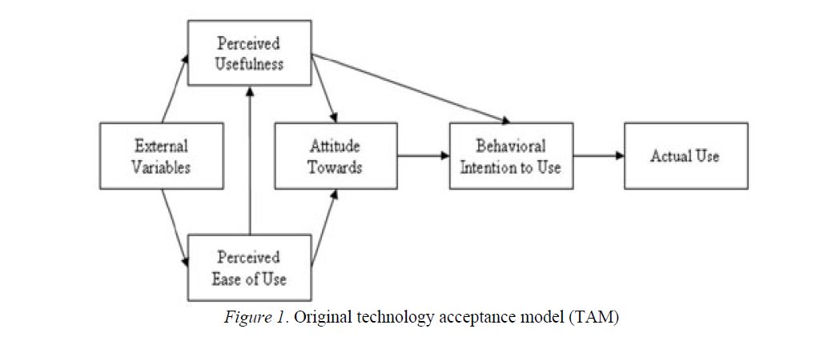

Based on this TAM we can summarize the variables related to the behavioral intention to use information technology or to the actual use of information technology could be grouped into four categories: individual context, system context, social context, and organizational context. Social context means social influence on personal acceptance of information technology use, while organizational context emphasizes any organization’s influence or support on one’s information technology use. The system visibility and system accessibility are as organizational context variables.

RESULT AND DISCUSSION
This research used the variables from TAM theory to compose the focus group discussion questions. The questions covered some of issues such as: the use of the internet attitude, the perceived usefulness, and perceived ease of use to collect the basic problems. Focus group discussion was conduct in two hours with involving 10 college students in two different groups in a row.
The informants were chosen randomly from communication faculty students of University Bina Darma Palembang. The reason why choosing the communication students are because they have learnt about mass media especially internet in their curriculum, they are in the young age range based on the Indonesia regulation and the last reason their campus provide 24 hours hot spot to access internet.
The first issue that comes up from the focus group session is every student has different experience with the internet, and also with the online shopping system. This different experience is based on their familiarity with the internet itself and the online shopping itself. More to explore the different experience is affected by their background knowledge about internet and online shopping. The students who thinks that they are familiar enough with the internet has more courage to try online shopping than the students who are not familiar enough with the internet.
The second issue is the level of trust, not every student has a trust to the online shopping system. Most of them even it is a big risk to have a transaction in the internet. Again, the level of the familiarity to the internet and to the certain online shopping system are affected their level of trust to the internet transaction. Their level of insecurity is complex. Most of them have a doubt to do online transaction in the internet, but they more do not mind to put their privacy identity to the online shopping system. Privacy is not a big concern for this teenage, money it is.
The last issue that showing up in the case of online shopping behavior, is the pressure from their peer group. When the online shopping becomes a trend topic to their peer group, they tend to have more bravery to know and to try online shopping system. The transfer of the knowledge of advance technology between the advance users to the first user is also happen during their socialization in the peer group. The level of trust is also increase rapidly if one of their peer groups has tried the online shopping system and success.

CONCLUSION
From the focus group discussion result we can have at least three big issues around young age towards their attitudes into the online shopping system. The different knowledge and background experiences with the internet will affected their attitude to online shopping system. The level of trust from every students is also influence their attitudes when they use and exploring the online shopping system. At least issue, peer group pressure should be count if we want to studying the young age behavior towards online shopping behavior. This research is an early research to conduct more and deep future research for comprehensive result, in order to predict the online shopping behavior of young age.

REFERENCES
[1] Miftachul, Andi. 2012. Indonesian E-Commerce Transaction in 2012 worth IDR2.5 Trillion. http://en.dailysocial.net/post/indonesian-e-commerce-transaction-in-2012-worth-idr2-5-trillion. diakses 17 September 2012
[2] Purbo, Onno W. 2000. Membangun Web e-commerce. Jakarta. PT. Elex Media Komputindo
[3] Miftachul, Andi. 2012. Indonesia Fashion E-Commerce, Will it Bloom? http://en.dailysocial.net/post/indonesia-fashion-e-commerce-will-it-bloom diakses 17 September 2012.
[4] Davis, F. D. (1989), "Perceived usefulness, perceived ease of use, and user acceptance of information technology", MIS Quarterly 13(3): 319–340
[5] Legris, P., Ingham, J., & Collerette, P. (2003). Why do people use information technology? A critical review of the technology acceptance model. Information & Management, 40, 191–204.

