AN ANALYSIS OF THE LEVEL OF INFORMATION TECHNOLOGY (TI) SERVICE SATISFACTION (A CASE STUDY OF GOJECK APPLICATION)

Lin Yan Syah
linyansyah@gmail.com

Siti Nurhayati Nafsiah
sititantointanapik@yahoo.co.id

Abstract
“An Analysis of the Level of Information Technology (TI) service satisfaction (A Case Study of Gojek Application)”.
As a company which engages in the field of Information Technology (TI) services for ojek online transportation, PT. Gojek Indonesia is influenced by the presence and customer loyalty. The researcher measured the level of customer satisfaction by using 70 respondents. The researcher used Quality Service model which was developed by Parasuraman, Zeithaml, and Berry in 1985. This model consists of five dimensions : Tangible, Reliability, Responsiveness, Assurance, and Empathy. The result of investigation showed that the level of customer satisfaction was low for each presentation of dimension statement. It could be concluded that respondents (customers) stated that Information Technology (TI) application had not worked well yet based on the facts that the customers faced in their life.

Keywords: Transportation, customer service, Gojek Information Technology (TI) Application.

- STUDY BACKGROUND
The use of information systems (SI) and information technology (IT) does not see the size of an organization. Diverse human needs result in information technology going forward and developing. One of the basic human needs is that they want their communication needs resolve quickly and efficiently so it does not waste a lot of time and effort. This need makes mobile technology more developed. One example of mobile technology is an Android smartphone.
Ojek ordered through the internet (online) which is widely used on Android is known as Gojek. This mode of shuttle transportation using online gadget or smart phone calling media began in June 2010 and the founder or CEO is Madine Makarin as the CEO, Brian Cu and Michaelangelo Moran. Today, the attention to customers’ satisfaction and dissatisfaction has been greater because basically the purpose of a company is to create a sense of satisfaction of the customer. Juniartono's research (2013) on the level of service satisfaction of CV. Delta Trans obtained the difference between consumer perceptions of services received with consumers’ hope toward the services that will be received. From this research, it interpreted that IT services existence on a quality Gojek application will affect consumer satisfaction. Satisfied consumers can be an effective source of marketing for companies, one of which is by recommending IT services of the Gojek application to other parties to increase the number of Gojek customers. The level of satisfaction has also been examined by Syarif (2014), and Wibowo (2015). The research conducted the assessing service quality by adopting user satisfaction measured from tangible, empathy, responsiveness, reliability, and assurance (Parasuraman et al. 1985).
Satisfaction in serving customers is the performance reflection of service companies, including PT. Gojek Indonesia Palembang. The number of Gojek customers that are not yet known and that are spread demographically is the company's dilemma in knowing the level of customer satisfaction. From this plan, the authors made "Analysis of IT Service Satisfaction Level (Case Study on Gojek Application)".

2. RESEARCH METHOD
2.1 Place and Time of Research
This research took place at PT. Gojek Indonesia (Palembang Branch) JalanBasukiRahmat No. 1608 B-D Palembang.
2.2 Research Method
This study used a quantitative descriptive approach. Quantitative approach is a research approach that carried out by processing and presenting data using statistical calculations involving numbers or scores / values to enable researchers to make decisions objectively. The using ofthis approach was because it was relevant to the problem formulationof this study which was trying to describe and know the gap of the variables under study.

2.3 Flow of Research Activities
The flow of this research activity was expected to help and be able to reach the target according to what was desired. To streamline this research activity carried out on a regular basis, namely with the form of systematic stages such as the picture below:
Figure 1Flowchart of Research Activities

3. RESULT AND DISCUSSION
3.1 Validity Test and Reliability Test
From the results of the instrument trials conducted on 70 respondents showed the results of the validity test consisting of 7 items tangible variable statements (X₁), 10 items empathy variable statements (X₂), 9 responsiveness variable statement items (X₃), 7 reliability variable statement items (X₄), and the 6 items of the assurance variable statement(X₅) were valid which considered to fulfill the requirements with r_{count}>r_{table} (0.235). This means that all statement items in the instrument could be used as indicators as valid measurement tools in next analyzes.
From the results of the tangible variable reliability test (X₁) consisted of 7 item statements, the Cronbach'sAlpha correlation value was 0.944. In the empathy variable reliability test (X₂) consisted of 10 item statements, the Cronbach's Alpha correlation value was 0.96. In the responsiveness variable reliability test (X₃) consisted of 9 item statements, the Cronbach's Alpha correlation value was 0.955. Reliability variable reliability test results (X₄) consisted of 7 item statements, Cronbach's Alpha correlation value was 0.942. And from the results of the assurance variable reliability test (X₅) of the 6 item statements, the Cronbach's Alpha correlation value was 0.938. For all variables it found that the correlation was in a strong correlation when compared to r_{table} (0.235) so that it could be concluded that the questionnaire was reliable.
3.2 Respondent Characteristics
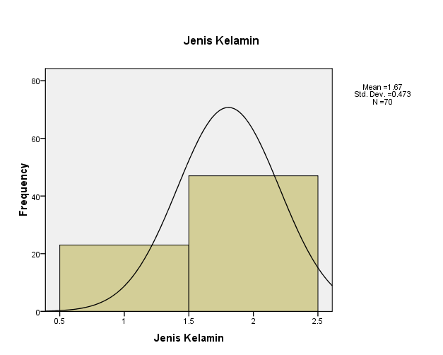Source: Analyzed Data, 2019, SPSS 17
From the diagram above shows that respondents who answered the questionnaire were respondents who were male as many as 23 respondents or equal to (32.9%) and female as many as 47 respondents or equal to (67.1%).
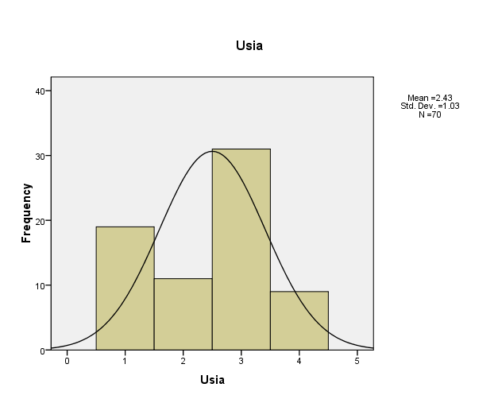
Source: Analyzed Data, 2019, SPSS 17
From the data generated in the diagram above shows that most of the respondents were 31 respondents (44.3%) aged 31 to 40 years, for ages less than 20 years as many as 19 respondents (27.1%), ages 20 to 30 years as many as 11 respondents (15.7%), ages 41 to 50 years were 9 respondents (12.9%), while there were no respondents (0.0%) for ages over 50 years.
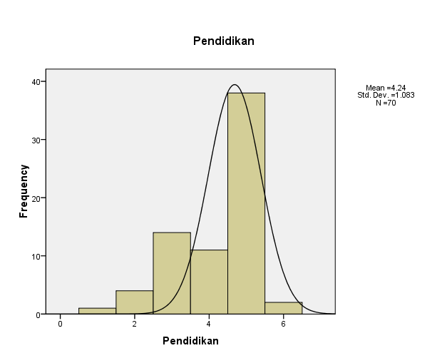
Source: Analyzed Data, 2019, SPSS 17
Based on the latest education level as the results of data processing above, the IT service users/customers in the Gojek application are mostly under graduate, namely 38 respondents (54.3%), the rest are 14 respondents (20.0%) with high school education, 11 respondents (15.7%) had Diploma education, 4 respondents (5.7%) had junior high school education, 2 respondents (2.9%) had graduate/post-graduate education and 1 respondent (1.4%) had elementary school education.
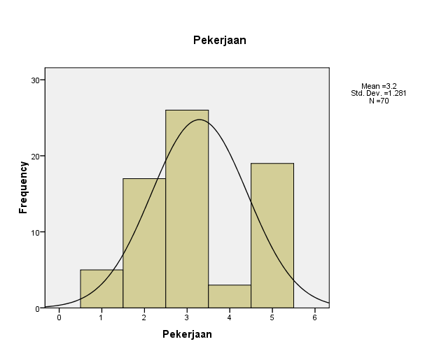
Source: Analyzed Data, 2019, SPSS 17
From the data generated in the diagram above shows that the users / customers of IT Services in the Gojek application mostly work as entrepreneurs as many as 26 respondents (37.1%), the rest work as private employees namely 17 respondents (24.3%), Civil Servant/State-Owned Enterprises employee as many as 5 respondents (7.1%), Indonesian Army/Indonesian Police as many as 3 respondents (4.3%), and 19 respondents (27.1%) having employment status outside of the written job choices.

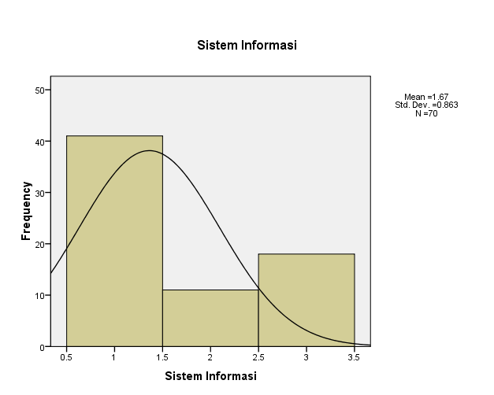
Source: Analyzed Data, 2019, SPSS 17
Based on respondents' information sources to get Gojek applications as the results of data processing above, it could be seen that users/customers of IT Services in the Gojek application mostly got it from information from friends or family of 41 respondents (58.6%), from advertisements (print media) as many as 18 respondents (25.7%), as well as from workplaces as many as 11 respondents (15.7%).
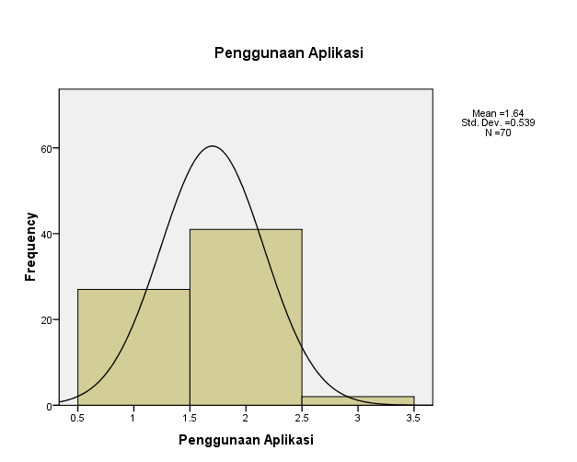
Source: Analyzed Data, 2019, SPSS 17
From the data above shows that users/customers of IT services in this application have used Gojek IT services applications as much as 6 to 10 times, namely 41 respondents (58.6%), 0 to 5 times by 27 respondents (38.6%), and those who have used the Gojek application more than 10 times as many as 2 respondents (2.9%).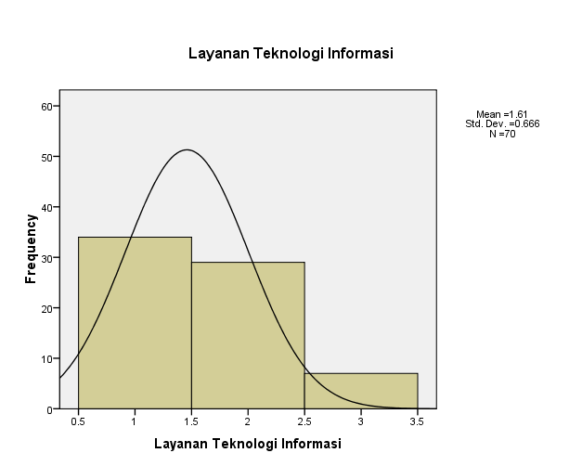
Source: Analyzed Data, 2019, SPSS 17
From the data above shows that most of the users/customers of Gojek have used Go-ride services applications as many as 34 respondents (48.6%), Go-food as many as 29 respondents (41.4%), and the rests were respondents who did not use other IT services which were unwritten on the questionnaire.
3.3 Frequency Variable
No | Variable/Dimension | Level of Satisfaction (%) |  |  |  |  | Des
 |  | VS | S | LS | NS | VD
1. | Tangible | 14,2% | 22,9% | 50,0% | 10,0% | 2,9%
2. | Emphaty | 11,4% | 25,7% | 52,9% | 5,7% | 4,3%
3. | Responsiveness | 12,9% | 17,1% | 61,4% | 5,7% | 2,9%
4. | Reliability | 11,4% | 25,7% | 55,7% | 4,3% | 2,9%
5. | Assurance | 12,9% | 24,3% | 52,9% | 7,1% | 2,8%
Source: Analyzed Data, 2019, SPSS 17

1). TangibleVariable
From the results of each item as many as 7 statements tested on tangible variables, in the first statement, dominantly as many as 35 respondents (50.0%) stated that they were not satisfied, in the second statement as many as 35 respondents (50.0%) stated that they were not satisfied, in the third statement 39 respondents (55,7%) again expressed dissatisfaction, in the fourth statement 36 respondents (51.4%) stated they were not satisfied, in the fifth statement 37 respondents (52.9%) stated they were not satisfied, in the sixth statement 43 respondents (61.4%) stated less satisfied, and in the seventh statement as many as 43 respondents (61.4%) respondents again stated they were not satisfied. Then from the analyzed data, it showed that the respondents felt dissatisfied on the physical/tangible proof of IT services ofGojek application.

2). Empathy Variable
Based on the results of each item as many as 10 statements tested on the empathic variable, in the first statement, dominantly 37 respondents (52.9%) stated that they were not satisfied, in the second statement as many as 42 respondents (60.0%) stated that they were not satisfied, in the third statement 40 respondents (57.1%) again expressed dissatisfaction, in the fourth statement 40 more respondents (57.1%) stated that they were not satisfied, on the fifth statement 38 respondents (54.3%) stated they were not satisfied, the sixth statement 43 respondents (61.4%) stated dissatisfied, in the seventh statement as many as 46 respondents (65.7%) stated that they were dissatisfied, in the eighth statement 41 respondents (58.6%) stated that they were not satisfied, in the ninth statement 36 respondents (51.4%) stated they were not satisfied, and in the tenth statement 39 respondents (55.7%) again stated that they were not satisfied. Then from the results of the processed data it can be stated that respondents felt dissatisfied in the variable empathy/empathy IT services of the Gojek application.
3). ResponsivenessVariable
From the results of each item as many as 9 statements tested on the responsiveness variable, in the first statement, dominantly 35 respondents (50.0%) stated that they were not satisfied, in the second statement as many as 43 respondents (61.4%) stated that they were not satisfied, 40 respondents (57.1%) in the third statement again expressed dissatisfaction, 40 more respondents (57.1%) in the fourth statement stated that they were not satisfied, in the fifth statement 40 respondents (57.1%) restated that they were not satisfied, in the sixth statement 44 respondents (62.9%) stated dissatisfaction, the seventh statement as many as 43 respondents (61.4%) stated that they were dissatisfied, 39 respondents (55.7%) in the eight statement stated they were not satisfied, and in the last statement as many as 42 respondents (60.0%) again stated that they were less satisfied. Then from the results of the processed data it can be stated thatrespondents felt dissatisfied on the responsiveness of IT services of Gojek application.
4). Reliability Variable
From the results of each item as many as 7 statements tested on the reliability variable, in the first statement, dominantly 39 respondents (55.7%) stated that they were not satisfied, in the second statement as many as 36 respondents (51.4%) stated that they were not satisfied, 39 respondents (55.7%) in the third statement again expressed dissatisfaction, in the fourth statement 40 respondents (57.1%) stated they were not satisfied, on the fifth statement 41 respondents (58.6%) stated they were not satisfied, 45 respondents (64.3%) in the sixth statement stated less satisfied, and in the seventh statement as many as 36 respondents (51.4%) respondents again stated they were not satisfied. Then from the processed data, it stated thatrespondents felt dissatisfied in reliabilityvariable of the IT service of Gojek application.
5). Assurance Variable
Based on the results table of each item as many as 6 statements tested on the assurance variable, in the first statement,dominantly37 respondents (52.9%) stated that they were not satisfied, in the second statement as many as 41 respondents (58.6%) stated that they were not satisfied,41 respondents (58.6%) in the third statement again expressed dissatisfaction, in the fourth statement 42 respondents (60.0%) stated that they were not satisfied, on the fifth statement 41 respondents (58.6%) stated they were not satisfied, and 41 respondents (58.6 %) in the sixth statement stated that they were not satisfied. Then from the processed data, it stated thatrespondents felt dissatisfied toward the IT service assurance variable ofGojek application.

4. CONCLUSION
1. In order to analyze the level of satisfaction of IT services in Gojek application was by making a questionnaire on Gojek application customers’ level of satisfaction.
2. IT Service of Gojek application users were dominated by women, ranging in age from 31-40 years old, mostly with undergraduate education and working as private employee. They also got the information from friends/family that had more than 6-10 times using the Gojekapplication Gojek, especially Go-Ride. From the analyzed table data of each dimension of service quality consisting of Tangible, Emphaty, Responsiveness, Reliability, and Assurance mostly respondents answered less satisfied. This means that what respondents (users/customers) expect from IT services in Gojek application was not in accordance with the reality in the field.
3. PT. Gojek Palembang should able to offer better and maximum services through online motorcycle taxi booking services and IT services on other Gojek applications. Therefore the IT service users/customers of the Gojek application will increase and feel satisfied and of course the Gojek application in Palembang will continue to last for a long time in the future.

REFERENCES
Azwar, Saifuddin. 2003. ReliabilitasdanValiditas. Yogyakarta: PustakaPelajar.
BurhanNurgiyantoro, dkk. (2000). StatistikaTerapanuntukIlmu – IlmuSosial. Yogyakarta: GadjahMada University Press.
Daniel, Elizabeth ;Storey, Chris. (1997). Strategic and Management Challenges.
Gde Dharma Putra, Cokorda. (2011). AnalisisKepuasanPelangganpada Perusahaan Daerah AirMinum (PDAM) di KabupatenJembrana. Tesis. Denpasar :UniversitasUndaya Denpasar.
Ghosh, Shikhar. (1998). Making Business Sense of the Internet.
Hamill, J, and Gregory, K,1997, Internet Marketing in the Internationalization of UK SMEs, Journal of Marketing Management, Vol 13. pp. 9-28.
Hasan, Iqbal. 2006. Analisis Data PenelitiandenganStatistik. Jakarta: BumiAksara
Juniartono. (2013). Analisis Tingkat kepuasanPelayananKonsumenPenggunaJasaTransportasipada CV. Delta Trans denganMenggunakanMetodeServqual. PelitaInformatika Budi Darma, Volume : V, Nomor: 2- SSN : 2301-9425.
Kalakota Dan Whinston, Frontiers Of Electronic Commerce, Addison-Wesley Publilshing Company, Inc, Massachusetts, 1996.
Khisty&Lall. 2005. Dasar-dasarRekayasaTransportasi. Jilid II Jakarta: PenerbitErlangga.
Oktaviani. AnalisisUjiKomparasiSistemOperasipada Android dan Blackberry. Paper oktaviani@staff.gunadarma.ac.id.
Oodan, Antony ; Ward, Keith ; Savolaine, Catherine ; Daneshmand, Mahmoed and Hoath, Peter (2008).. The Institution of Engineering Telecommunications Quality ofService Management and Technology, London, United Kingdom.

Parasuraman, A, Valarie A. Zeithaml, and L. Berry (1985). “A. Conceptual Model of Service Quality and Its Implications for Future Research”, Journal Marketing, Vol. 49 (Fall), pp. 41-50.
Suyanto, M. 2003. E – commerce Perusahaan Top Dunia. Andi. Yogyakarta.
Syarif, MS. (2014). AnalisisPengaruhKepuasanPelangganBuswayTerhadapAdopsiInovasiSistimTiket Tunggal Elektronik Smart Card UntukMendukungIntegrasiModaTransportasiMassal di Jakarta. IncomTech, Jurnal Telekomunikasi danKomputer, Vol 5, No. 3.
Wendha, A.A AyuAtikaParamitha ;Rahyuda, I Ketut ; Suasana I. Gst. A. Kt. G. (2013). PengaruhKualitasLayananTerhadapKepuasandanLoyalitasPelanggan Garuda Indonesia di Denpasar. JurnalManajemen, StrategiBisnis, danKewirausahaan Vol. 7, No. 20.
Wibowo, Tri. (2015). PengaruhKualitasPelayananTerhadapKepuasanKonsumenpada PT. JNE. Skripsi. Surakarta :UniversitasMuhammadiyah Surakarta.
Zeithamldan Berry (1995) dan Cronin dan Taylor (1994). ”Service Quality, Jurnal Marketing American Association”, DiterjemahkanolehParasuraman.

Zeithaml, Valerie, A., and Bitner, Mary Jo, 1996, Service Marketing, Singapore : McGrow Hill.

