GOODS SALES INFORMATION SYSTEM ON SHOES MEADLEY PALEMBANG WEB-BASED ANALYSIS USING MARKET BASKET (MBA)

${Bruri Marantika}^{1}$, ${Afriyudi}^{2}$, ${Ria Andryani}^{3}$
${Student of Bina Darma university}^{1}$, ${lecturer Universitas Bina Darma}^{2,3}$
Jalan Jenderal Ahmad Yani No.12 Palembang
E-mail : ${bruri.SKY@gmail.com1.}^{}$

ABSTRAK
Computer software applications and the Internet has been growing rapidly at this time, as well as web applications and browsers Internet or intranet. Applications E-Commerce has long expansion begins with EDI (Electronic Data Interchange), which has grown in scope International. This study aimed to the store and shoppers in knowing what items will be purchased roughly simultaneously. In this study used the PHP programming language for ease of programming, and features for implementing e-commerce system, the ability to cross-platform, as well as ease of deployment for application developers. In this study, using the Market Basket Analysis, which is one of data mining techniques are used to determine which of the products to be purchased by customers simultaneously by analyzing the transaction list pelanggan.Hasil this study a value of support and confidence of each items purchased at the same time which has been determined based on the calculation method of the MBA.

Keywords: Keywords: E-commerce, Market Basket Analysis Methods

- Background
The development of information technology has contributed significantly to improving business activities, especially in terms of data processing that provides support for making business decisions and the development of information technology.
Medley Shoes is a shop that sells various types of shoes and other such complementary; socks and sandals. Previously, in the existing sales process for the sale of this recording is still using a manual system that is by writing the goods sold, then do the bookkeeping and calculation of sales every day, including the reporting of sales of goods.
In this case used is PHP and MySQL, because the script language that can be placed on the server in order to build a dynamic website to make it look as well as a database that can be used to store large amounts of data. using market basket analysis method which works by searching and finding patterns in association between the products being marketed.
Based on the above issues, the authors are interested in doing further research to take the title of the thesis is "Goods Sales Information System In Palembang Shoes

  - Research Problem
Based on the background of the problem, then the outline can be formulated problems contained in this thesis is "How to create an information system of selling goods on a web-based Medley Shoes by applying the method of Market Basket Analysis using the PHP programming language".

  - Scope Of Problem
The scope of the study is limited to avoid the expansion of subject matter that is not in accordance with the issues raised. Research and discussion are performed only on sales transactions online that will be able to attract customers to order and buy goods sold by Medley Shoes by using the Market Basket Analysis.

1.5. RESEARCH METHODOLOGY
1.5.1 Location and Time Research
The location of this research carried out at Medley Shoes Store is located at Jl. General Sudirman No. 2953 Palembang. Implementation of the time the study began in October 2014 through to February 2015.
1.5.2 Systems Development Method
The method used is the development of Web Engineering.
1. Formulation (formulation)
Activity that serves to formulate goals and size of web-based applications and set the limits of the system.
2. Planning (planning)
The event, which is used to calculate the estimated cost of the project is a web-based application creation, the estimated number of developers, the estimated development time, risk evaluation project development, and defines the development schedule for the next version (if required).
3. Analysis (analysis)
Activity to determine the requirements engineering requirements and identify the information that will be displayed on a web-based application.
4. Engineering (engineering)
There are two work performed in parallel, namely the design and information content of web architecture design.

5. Implementation (implementation) and testing (testing)
An activity to realize the design into a web site. The technology used depends on the needs that have been formulated in the analysis phase.

6. Evaluation (evaluation)
A final activity of web engineering process cycle, will determine whether a web that has been created in accordance with what they want. If the web-based application is not in accordance with their will, then the process will continue to be a web engineering and starts again from the formulation stage for the next version.

1.6 Methods of Market Basket Analysis
Market Basket Analysis or MBA is one of the types of data analysis that is most often used in marketing (Megaputer, 2007). The purpose of the Market Basket Analysis is to determine what products are most often purchased or used at the same time by the consumer. The process of market basket analysis is to analyze the buying habits of consumers to find associations between different products that put consumers in a shopping basket.

RESULTS AND DISCUSSION
4.1 Results
Results of this research is a website selling goods online in Palembang Shoes Medley created using the PHP programming language, in carrying goods sales information system is directly must have a local web server is Apache, the web has a main page or the front page is the index page which serves as the main page automatically when the web is accessed. This chapter will discuss the sale of goods in the information system Medley Shoes Palembang there are other pages that can be interconnected to one another. Expected to facilitate in providing information to prospective customers Medley Shoes Palembang on all matters relating to the sale of goods such as shoes price, type of shoes, and more.

4.2 Discussion
4.2.1 Home Page
Home page is the first page of the website in the sale of goods by using PHP.
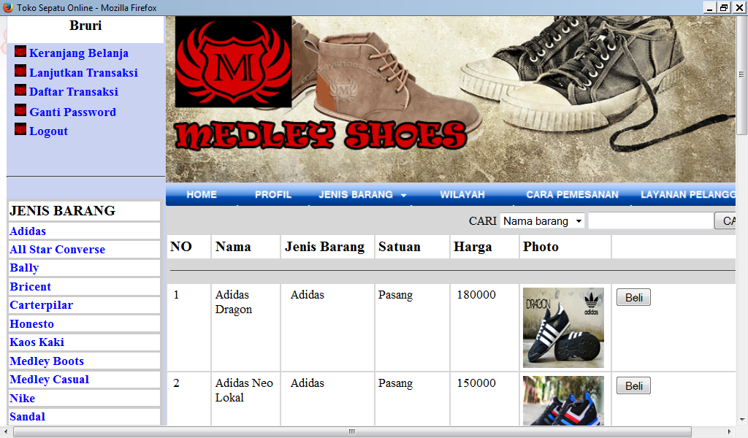

4.2.6 Shopping Cart page and Process Market Basket Analysis
This page is a page view shopping cart, on this page, or goods that have been ordered into the basket belanja.Pada Market Basket Analysis is a process view page MBA (Market Basket Analysis), here shown on any item that is about to be purchased in conjunction with the previous item that has been ordered or purchased.
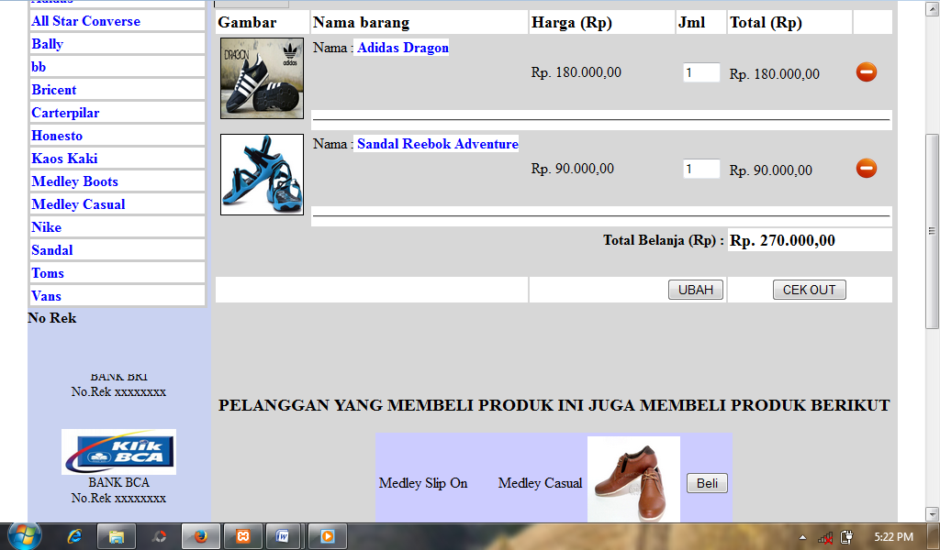

CONCLUSION
5.1 Conclusion
Based on the results of the research that has been done Medley Shoes In Palembang, the authors draw the following conclusion:
1. This research resulted in the sale of goods in the information system Medley Shoes Palembang using Market Basket Analysis Methods.
2. The information system of selling goods at Medley Shoes Palembang built with PHP programming language and MySQL database.
3. Make it easier to provide information to prospective customers Medley Shoes Palembang on all matters relating to the sale of goods such as the price of goods, the type of goods and others.
4. With the sale of goods using information adanyasistem Market Basket Analysis methods can facilitate the Medley Shoes in managing any item sold roughly simultaneously and purchased by consumers.

BIBLIOGRAPHY

Kris, Andri. 2008. Design of Information Systems and Applications
Style Media, Yogyakarta.

Witarto. 2004. Understanding Information Systems. Publisher Information. Jakarta
Whitten, Jeffrey L, et al 2007. Systems Analysis and Design Methods, Andi Offset, Yogyakarta.
Soemarsono. 2000. Accounting An Introduction. Rineka Reserved. Jakarta

Kotler, Philip. 2002. Marketing Management: Analysis, Design, Implementation, Control. Prenhallindo. Jakarta.

Widjajanto, Nugroho. 2001. Accounting Information Systems. Erland. Jakarta
Computer rides. 2006. What and How E-Commerce, Andi Offset, Yogyakarta.

