The 4th ICIBA 2015, International Conference on Information Technology and Business Applications Palembang-Indonesia, 21-22 February 2015

System Inventory Information to the Sales Division Of PT. Yerrico Putra Pratama Using FIFO (First In First Out)
Elvira Sefa Agnesa
Universitas Bina Darma
Evira744@yahoo.co.id
M. Izman Herdiansyah.S.T.,M.M.,Ph.D
Universitas Bina Darma
m.herdiansyah@mail.binadarma.ac.id
Ria Andryani.M.M.,M.Kom
Universitas Bina Darma
ria@mail.binadarma.ac.id

Abstrack
PT. Yerrico Putra Pratama is a form of business entity that is engaged in LPG. PT. Yerrico Putra Pratama need for a computerized system that is more accurate, fast, and efficient in knowing the information and inventory data. But in reality it is sometimes not in accordance with the wishes and expectations. Because of the limited computerized systems used in the PT. Yerrico Putra Pratama. Inventory items used by PT. Yerrico Putra Pratama still use the recording manually by using the book, then the common difficulties such as the difficulty to find the data item. Writing is using FIFO (First In First Out) with the aim of analyzing the system that runs on the PT. Yerrico Putra Pratama. The results of this paper can provide positive benefits for PT. Yerrico Putra Pratama.
Keywords : Inventory, Systems, Computerized, FIFO.

- INTRODUCTION
  - Background
PT. Yerrico Putra Pratama is a company engaged in the distribution of LPG Pertamina. In the data recording product, price and quantity of goods shipped from the supplier until the goods have been stored in the warehouse, the company already has a data flow in and out good but the system is still using manual recording so many problems eventually emerge. Such as difficulty controlling the goods in, out or inventory, due to the information presented to be less effective and efficient. System inventory information is very important to support the operations of a company. System Information needed company, especially on inventory with computer applications, is expected to accelerate in completing the work and the company produced accurate data with a faster time. First In First Out (FIFO) is an abstraction that is related to how to organize and manipulate data relative to time and priorities.

  - Research Problem
Based on the background mentioned above which outlines that PT. Yerrico Putra Pratama wishes to have an information system inventory system that can replace the existing stock of goods, but still run it manually, the formulation of the problem is "How to make the system inventory information on PT. Yerrico Putra Pratama using the method of recording first in first out? "Which is expected to provide comfort for the users of the system.

  - Objectives and Benefits Research
for data processing inventory at PT. Yerrico Putra Pratama using the method of recording first in first out (fifo). Companies can apply these results by entering into the work programs that have been compiled by the company. With the results of this report will improve the understanding of the author by applying the knowledge gained in the discipline.

  - Systems Development Method
To create an application system takes several steps in order to obtain an application that is really useful as needed.
According to Pressman (2010) stages in the development of the system are as follows:
1. Planning System (System Planning)
Namely the early stages of system development that defines the estimated resource needs such as physical devices, human, methods (engineering and operations) and the budget of a general nature.
2. Analysis System
That phase of the study on the existing system with the aim of designing a new system or updated.
3. Design System
That is the stage after the analysis system that determines the process and data required by the new system.
4. Implementation System
That is the stage where the design of the system is formed into a code (program) that is ready to dioperasian.
5. Maintenance System
That step is performed after the implementation phase, which includes the use of or use of, the audit system, maintenance, repair, and improvement of the system.

- RESEARCH METHODOLOGY
  - Information Systems
According to O'Brien (2005, p703), an information system on a regular combination of people, hardware, software, network communications, and resource data to collect, transform, and distribute information within an organization.
According to Hall (2001, p7), the information system is a series of formal procedures by which data are collected, processed into information, and distributed to users.
From the opinion of experts, it can be concluded that the system resource information is collected and processed data into information, and distributed to users.

  - Stock
Understanding inventory according to Agus Ristono (2009: 1) states that: Inventory can be interpreted as the goods are stored to be used or sold in the past or future periods. Inventories consist of raw materials, semi-finished goods inventory, and finished goods inventory.
Inventory by Moh. Benny Alexandri (2009: 135) states: Inventory is an asset that melipiti goods belonging to the company with the intent to sell within a certain period of effort, a stock of goods which are still in progress, the process of production or supply of raw materials awaiting use in a production process.
From the above understanding can be concluded that the supply of a resource-organizational resources stored in anticipation of the fulfillment of the request

  - FIFO (First In First Out)
According to Donald E. Kieso, Jerry J. Weygandt and Terry D. Warfield translated by Emil Salim (2002: 460) states that: "The FIFO method assumes that the first goods purchased are the first items that are used (in the manufacturing or sale of the company trade), therefore, available supply is the most recent purchased goods ".
According to the Finance Accounting Standards (2002: 14.5) stated that:
"Formulation PNPM or FIFO assumes first purchased goods in stock will be sold or used in advance so that is left in the inventory is purchased or in production later."
Of the opinions can be concluded that this method emphasizes the current value corresponding to the flow of goods for the first value of inventory acquired or previous purchases directly charged to current operations, so that the value of the remaining inventory is the last purchase.

- RESULT AND DISCUSSION
  - Design System
The design data management system is a picture with a computer and a comprehensive description of the sequence of preparatory design data management system to generate the required reports.

    - Context Diagram
SPPBE entity, provide the data to the data processing applications SPPBE inventory, then the entity SPPBE gets invoice ordering goods, entities providing goods data warehouse, the data of goods in and out and all the data items in the form of reports SPPBE reports, reports of goods, incoming goods report, report goods out and report inventory.

Figure 3.1 Context Diagram

    - Form Login
Login is the initial form when the user wants to run the program. In this login form contained the username and password fields, Use to enter user id and password. The login screen at run time are as follows:

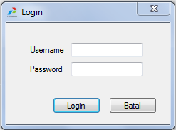
Figure 3.2 Form Login

    - Incoming Goods
Goods Login Form Item Used to display the Sign, Inside there are columns to input the amount of goods entering

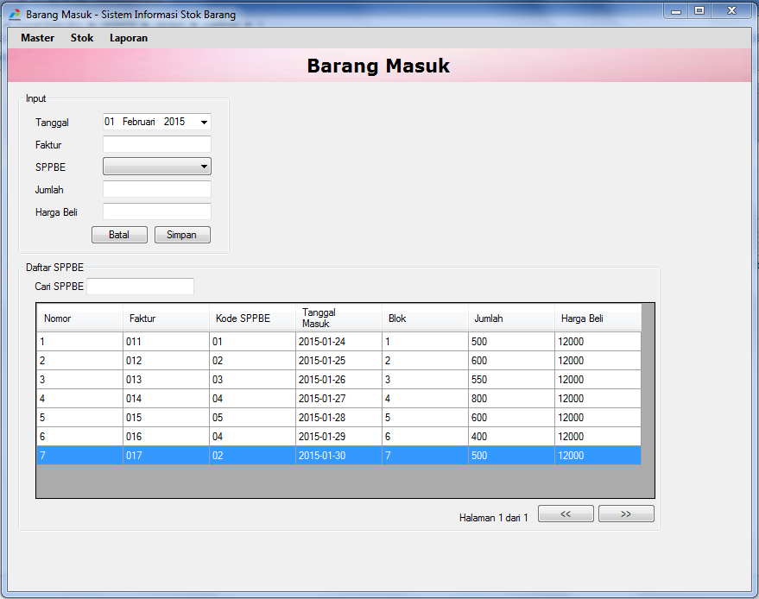
Figure 3.3 Incoming Goods
    - Exit Item
Documenting stuff out is used to display the Data Collection Form Exit Goods

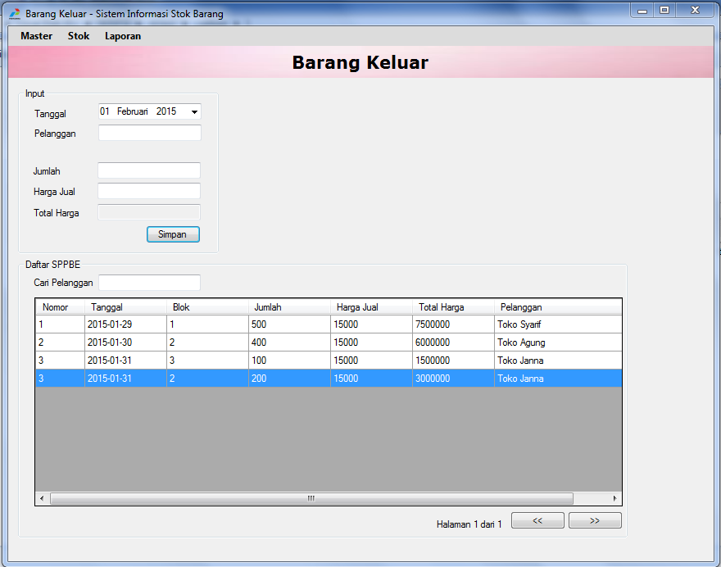
Figure 3.4 Exit Item

- CONCLUSION
From all the results of the discussion presented in the previous chapters, it can be concluded:
1. The resulting system is a Stock Information System Application Goods In. Yerrico Putra Pratama created using Microsoft Visual Basic. net 2008
2. Goods Stock Information System is indispensable for the smooth and effective in data processing inventory and helps the staff employees in PT. Yerrico Putra Pratama in addressing the problems that occur in order to produce accurate information.

5. REFERENCES
Wandi, Muhammad. 2014. Pengertian Persedian.
http://elib.unikom.ac.id/files/disk1/450/jbptunikompp-gdl-muhamadisw-22485-2-babiiw-i.pdf
Pressman 2010. Metode Waterfall.
http://cisenaextreme99.blogspot.com/2013/06/metode-waterfall-menurut -pressman.html.
Munawaroh, Siti. 2006. “Perancangan Sistem Informasi Persediaan Barang”. Semarang: Teknologi Informasi
S.E., M.Si. Hery. 2013. Akuntansi Keuangan Menengah

