Packet Tracer –Investigating a VLAN Implementation
Topology
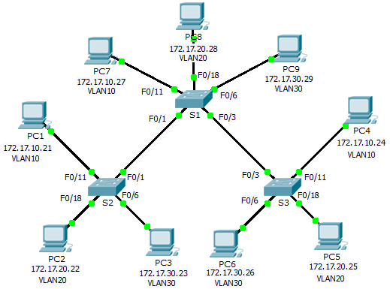
Addressing Table
Device | Interface | IP Address | Subnet Mask | Default Gateway
S1 | VLAN 99 | 172.17.99.31 | 255.255.255.0 | N/A
S2 | VLAN 99 | 172.17.99.32 | 255.255.255.0 | N/A
S3 | VLAN 99 | 172.17.99.33 | 255.255.255.0 | N/A
PC1 | NIC | 172.17.10.21 | 255.255.255.0 | 172.17.10.1
PC2 | NIC | 172.17.20.22 | 255.255.255.0 | 172.17.20.1
PC3 | NIC | 172.17.30.23 | 255.255.255.0 | 172.17.30.1
PC4 | NIC | 172.17.10.24 | 255.255.255.0 | 172.17.10.1
PC5 | NIC | 172.17.20.25 | 255.255.255.0 | 172.17.20.1
PC6 | NIC | 172.17.30.26 | 255.255.255.0 | 172.17.30.1
PC7 | NIC | 172.17.10.27 | 255.255.255.0 | 172.17.10.1
PC8 | NIC | 172.17.20.28 | 255.255.255.0 | 172.17.20.1
PC9 | NIC | 172.17.30.29 | 255.255.255.0 | 172.17.30.1
Objectives
Part 1: Observe Broadcast Traffic in a VLAN Implementation
Part 2: Observe Broadcast Traffic without VLANs
Part 3: Complete Reflection Questions
Background
In this activity, you will observe how broadcast traffic is forwarded by the switches when VLANs are configured and when VLANs are not configured.
- Observe Broadcast Traffic in a VLAN Implementation
  - Ping from PC1 to PC6.
    - Wait for all the link lights to turn to green. To accelerate this process, click Fast Forward Time locatedin the bottom yellow tool bar.
    - Click the Simulation tab and use the Add Simple PDUtool. Click on PC1, and then click onPC6.
    - Click the Capture/Forwardbutton to step through the process. Observe the ARP requests as they traverse the network. When the Buffer Fullwindow appears, click the View Previous Events button.
    - Were the pings successful? Why?
    - Look at the Simulation Panel, where did S3 send the packet after receiving it?
In normal operation, when a switch receives a broadcast frame on one of its ports, it forwards the frame out all other ports. Notice that S2 only sends the ARP request out Fa0/1 to S1. Also notice that S3 only sends the ARP request out F0/11 to PC4. PC1 and PC4 both belong to VLAN 10. PC6 belongs to VLAN 30. Because broadcast traffic is contained within the VLAN, PC6 never receives the ARP request from PC1. Because PC4 is not the destination, it discards the ARP request. The ping from PC1 fails because PC1 never receives an ARP reply.
  - Ping from PC1 to PC4.
    - Click the Newbutton under the Scenario 0dropdown tab. Now click on the Add Simple PDU icon on the right side of Packet Tracer and ping fromPC1 to PC4.
    - Click the Capture/Forwardbutton to step through the process. Observe the ARP requests as they traverse the network. When the Buffer Fullwindow appears, click the View Previous Events button.
    - Were the pings successful? Why
    - Examine the Simulation Panel. When the packet reached S1,why does it also forward the packet to PC7?
- Observe Broadcasts Traffic without VLANs
  - Clear the configurations on all three switches and delete the VLAN database.
    - Return to Realtime mode.
    - Delete the startup configuration on all 3 switches. What command isused to delete the startupconfiguration of the switches?
    - Where is the VLAN file stored in the switches?
    - Delete the VLAN file on all 3 switches. What command deletes the VLAN file stored in the switches?

